Erdogan’s Assault On Rojava Rages On
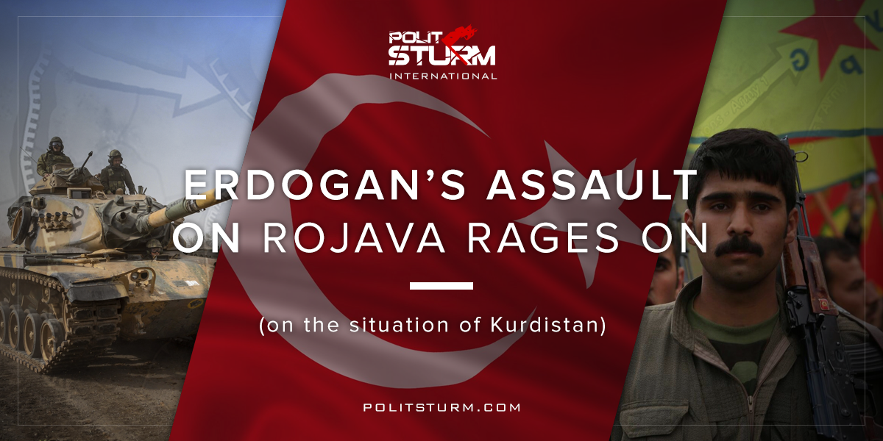

Original article
2018-03-13
11 min read

Despite a countrywide United Nations brokered ceasefire agreement, Erdogan has stated that the agreement will not hinder Turkish military actions in Afrin, in Kurdish-inhabited Northern Syria. The current conflict is believed to have killed 270 YPG fighters, 44 Turkish soldiers, and 241 pro-Turkey rebels, as well as displaced at least 15,000 from the region.
In January, Turkey’s President Recep Erdogan launched a military assault on Rojava, the Kurdish held-areas in Northern Syria (Now called The Democratic Federation of Northern Syria [DFNS] as of late 2016). Erdogan, who labels the Kurdish resistance operating in Turkey as terrorists, stated that he will “strangle” and “bury” every Kurdish region. Turkey’s General Staff dubbed the attack on Afrin “Operation Olive Branch”.
Most military activity has been centered around the Afrin canton, home to 500,000 kurds and refugees, that has been the target of Turkish jet fighters. Rojhat Roy, a YPG spokesman in Afrin, has called the bombing campaign the largest that the Turkish military have launched against the Kurds throughout the entirety of the Syrian Civil War.
Turkish Defense Minister Nurettin Canikli originally stated that no Turkish troops had entered Afrin, however, reports from Turkish newspapers claim that 20 buses carrying Free Syrian Army rebels crossed over the border into the Turkish-held area of Northern Syria.
Erdogan stated on in late January that the operation would continue with a push towards the city of Manbij, taken from the Islamic State by Kurdish forces in 2016.
For their part, the Americans have publicly criticized the shelling of Afrin stating they do not believe it “serves the cause of regional stability” and called on them instead to focus their efforts on Islamic State militants. Erdogan responded by stating that the United States must “cut support given to terrorists” if it wants to avoid a confrontation. The move puts the US in an uneasy situation as the invasion, conducted by a fellow NATO member, could erase any possibility for a pro-American force in the Syrian conflict. Complicating matters for the Kurds is the fact that the US currently operates at least 10 illegal military bases in Kurdish held territory, which Secretary Mattis has stated will not be leaving in the near future.
Q: You know, Assad says Iran and Russia were invited into his country, you were never invited in; you’re there illegally. What legal standing do you have to — to you know, be in Syria?
SEC. MATTIS: You know, the U.N. said that ISIS — basically we can go after ISIS. And we’re there to take them out. But that doesn’t mean we just walk away and let ISIS 2.0 pop back around? as if we’re surprised either. So we got to get the U.N.-brokered effort in Geneva to take this thing forward.
Russian armed forces were withdrawn from the Afrin area, something that Russian Foreign Minister Sergei Lavrov had originally denied on January 20th. It was reported that Russia officials asked the Syrian Kurds to hand Afrin over to the Syrian national government to prevent the Turkish attacks, a decision the leadership flatly refused. On Thursday, Turkey sent its military chief to Moscow to meet with Chief of Staff Valery Gerasimov to seek Russian approval for airstrikes in the Afrin region. It remains to be seen if the two countries came to any agreement regarding the Kurds. YPG General Sipan Hemo stated that Russia had “betrayed the kurds”.
The Syrian government has previously warned that any Turkish fighter planes operating in Syria would be shot down. Syrian national SDF forces who entered Afrin in late February to counter the Turkish assault have been targeted by Turkish forces.
The YPG, a part of Rojava’s People’s Protection Units, have released a statement concerning the bombings:
“YPG is ready to confront Turkish troops and FSA terrorists. If they dare to attack, we are ready to bury them one by one in Afrin.”
In a defensive operation promptly named “Hunt for Wolves”, the YPG stationed some 1000 fighters on the Syrian-Turkish border in order to resist the assault. In all, there are believed to be between 8-10 thousand Kurdish fighters in the Afrin area.
The Iraqi Peshmerga pledged their support to the struggle on the condition that the DFNS and US-led coalition allow them to enter the country.
A group of prominent activists and academics, including Noam Chomsky and David Harvey, released a public statement urging the governments of the United States, Russia, and Iran to prevent Turkish aggression in area.
“An attack of this kind against the peaceful citizens of Afrin is a blatant act of aggression against a peaceful and democratically-governed region and population. Turkey cannot carry out such an attack without the approval of Russia, Iran and Syria – and inaction by the U.S. to stop it. The Kurdish people have endured the loss of thousands of young men and women who joined the YPG, and YPJ women’s force, to rid the world of ISIS. The U.S and the international community have a moral obligation to stand behind the Kurdish people now. We call on U.S. officials and the international community to guarantee Afrin’s stability and security and prevent further Turkish aggression from within Syria and across the Syrian border.”
Demonstrations have been held in major cities around the world including in Hannover, Germany where violence broke out between pro-Turkish and pro-Kurdish sides. The BBC reported that certain British leftists were leaving for Syria in order to join the fight against Turkey.
So, how should we as Marxists understand and interpret the Rojavan Revolution? The Kurdish people of Northern Syria have been attempting to create a decentralized society based on democratic, multiculturalist and feminist values, and for all intents and purposes, are the most progressive group in the modern Middle East. Is it, though, a principally Socialist Revolution in nature, in which the proletariat have destroyed the capitalist state and begun the process of socializing the means of production? Many Anarchists would have you believe it so, however, the fact that the Syrian Kurds never created a vanguard party representing and struggling in the interest of the working people, e.g. Marx’s “Dictatorship of the Proletariat”. Indeed, the main objective of a proletarian revolution is the overthrow of the bourgeois class and the creation of a socialist system. After noting on the advancements and failures of the Paris Commune, Engels proclaimed the following:
“In reality, however, the State is nothing else than a machine for the oppression of one class by another, and indeed no less so in the democratic republic than in the monarchy. At the best it is an evil inherited by the proletariat after its victorious struggle for class supremacy and whose worst features it will have to lop off at once, as the Commune did, until such time as a new generation, reared under new, free social conditions, will be in a position to rid itself of this State rubbish in its entirety.”
Engels, Introduction to “The Civil War In France”, 1891
First, like the commune, the DFNS has attempted to bring decentralized power in the middle of a civil war, a time when the movement should be focusing on struggling for survival over the forces of capital. If Rojava survives the Turkish assault, how long after will they continue to exist in their current state? Rojava is a small country in a part of the world known for its interregional conflicts and continues to be an ‘autonomous’ region inside of Assad’s Syrian state. The Europeans have a long history of making use of the Kurds when it suited their imperial interests and subsequently dropping all support for them, letting any promises to go unfulfilled. Before the revolution, Northern Syria was economically dependent on the rest of the Syrian state, supplying wheat, cotton, and oil to be refined in other parts of the country. Now with more economic sovereignty, a raging civil war, and an embargo, the Kurdish people have encountered trouble in developing. While ultimately, a revolution may not be “a dinner party”, the lack of a proletarian-run state to coordinate the revolution seriously puts into question whether the Kurds will be able to overcome these large hurdles.
Secondly, and most troubling is that the DFNS has retained many worrisome elements from its pre-revolutionary days, mainly private property ownership. Article 41 of the Social Contract of the Rojava Cantons is written as follows:
“Everyone has the right to the use and enjoyment of his private property. No one shall be deprived of his property except upon payment of just compensation, for reasons of public utility or social interest, and in the cases and according to the forms established by law.”
In its most recent version from 2017, the same protection is applied.
Moreover, Anarchist academic David Graeber, who toured the ‘anti-capitalist’ cantons, claimed that capitalism had never fully been done away with.
“A few indigenous capitalists do exist and have not been expropriated though; some are even part of the formal (largely Potemkin) “self-administration” government; the language used to justify this was that the revolution aimed to “change the ground under which they operated” by shifting the way the economy as a whole functioned, and to change the structure of political power so as to make it impossible for them to translate economic advantage into political influence, and thus ultimately, to continue to operate as capitalists in the long run.”
If this is true, then this poses a serious theoretical problem for the so-called “anti-capitalist” project. While it may be understandable for the construction of Socialism to take time (In the Soviet Union, collectivization and industrialization were not completed until the 1930s), to include capitalists in the governing party is a serious detriment to the democratic practice of the masses. Considering private property is protected and capitalists have power over the democratic process, what is to say that they will not struggle for more power over the working people? If 20th century socialism has shown us anything, it is that those working within the workers’ party can lead the movement away from the path of socialism and towards a restoration of full bourgeois capitalism. Apart from the communalist TEV-DEM alliance, there exists a strong Kurdish nationalist movement that could take power in the future and reverse the gains made by the left.
The Rojavan experiment, a theoretical amalgamation of various liberal and leftist doctrines, ranging from anarchism to feminism to ecosocialism, is nothing more than a struggle for national liberation. The Kurdish people, who have been split between four countries since the Sykes-Picot agreement, have been struggling for their independence for nearly a century and with the start of the Syrian civil war, the Kurdish people were given another chance. While there are obvious theoretical contradictions in the DFNS’s communalist doctrine, their struggle represents one against Turkish imperialism. No matter the form, any group of people that have undertaken a project contrary to that of global capital have been repressed. The turks, starting from Kemal Ataturk, prevented the creation of an independent Kurdish state in their repression of multiple Kurdish uprisings. Today, Erdogan and turkish nationalists fear a new uprising in Turkey with their Kurdish population if the Syrian Kurds are to succeed and this act of violence is only meant to continue the oppression of the Kurdish people as a whole.

Sources: 1, 2, 3, 4, 5, 6, 7, 8, 9, 10, 11, 12, 13, 14, 15, 16, 17, 18, 19, 20

Original article

