Engels on the Eventual Necessity for Communism
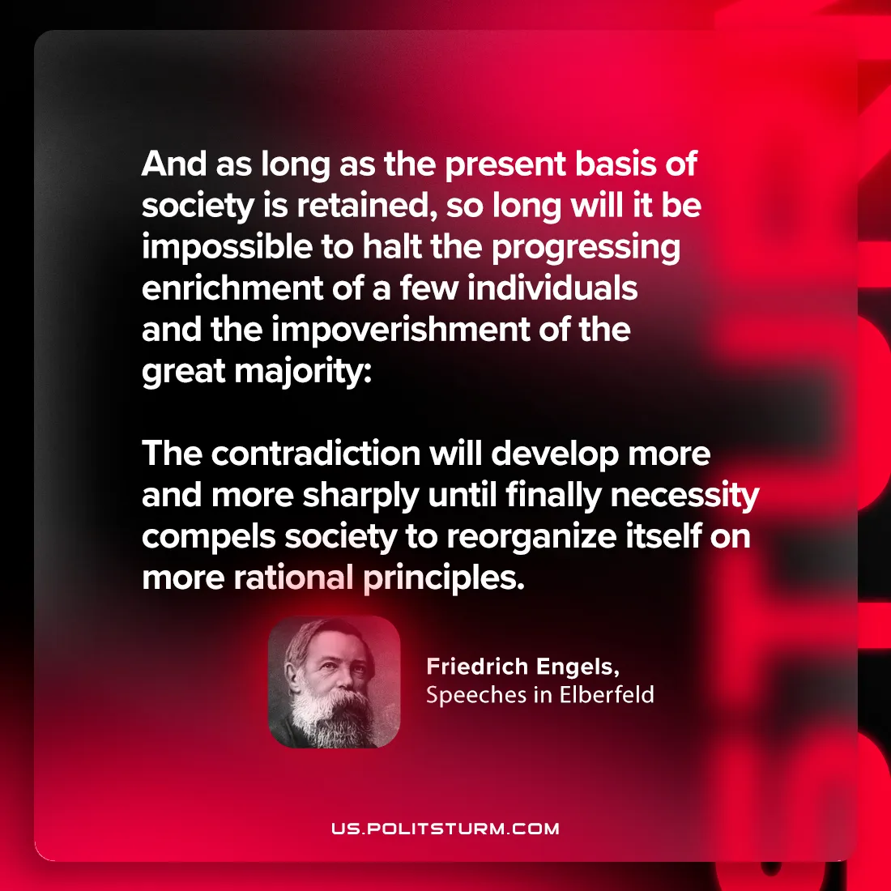

Original article
2024-09-08

“And as long as the present basis of society is retained, so long will it be impossible to halt the progressing enrichment of a few individuals and the impoverishment of the great majority: the contradiction will develop more and more sharply until finally necessity compels society to reorganize itself on more rational principles.”
Friedrich Engels, Speeches in Elberfeld

Original article

