Engels on What to Seek
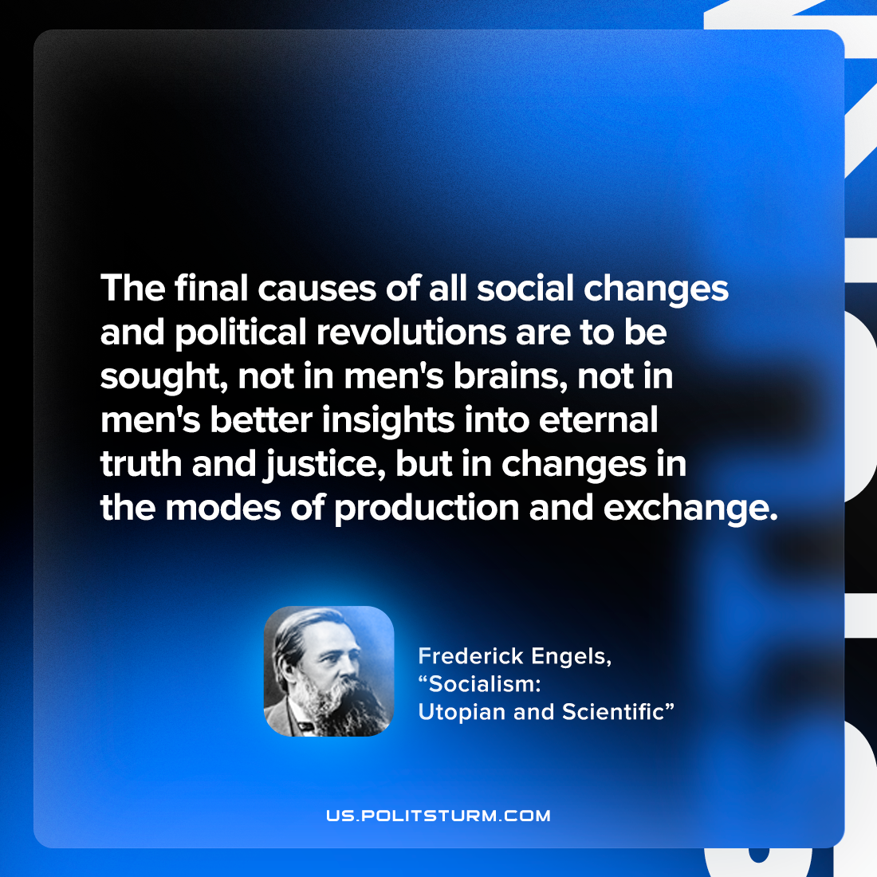

Original article
2022-10-22

The final causes of all social changes and political revolutions are to be sought, not in men’s brains, not in men’s better insights into eternal truth and justice, but in changes in the modes of production and exchange.

Friedrich Engels, “Socialism: Utopian and Scientific”

Original article

