Engels on War
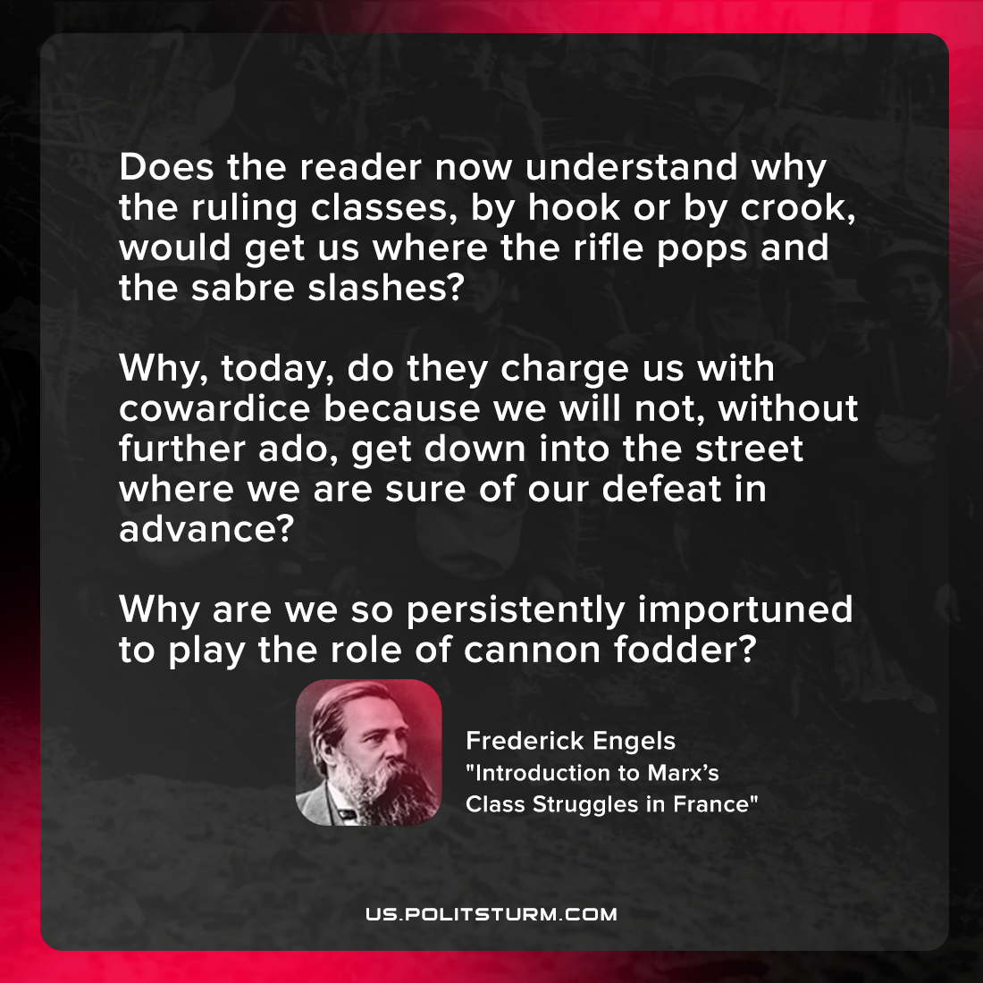

Original article
2021-10-07

Does the reader now understand why the ruling classes, by hook or by crook, would get us where the rifle pops and the sabre slashes? Why, today, do they charge us with cowardice because we will not, without further ado, get down into the street where we are sure of our defeat in advance? Why are we so persistently importuned to play the role of cannon fodder?

Frederick Engels, “Introduction to Marx’s Class Struggles in France”

Original article

