Engels on Transition of the Peasantry to the Proletariat
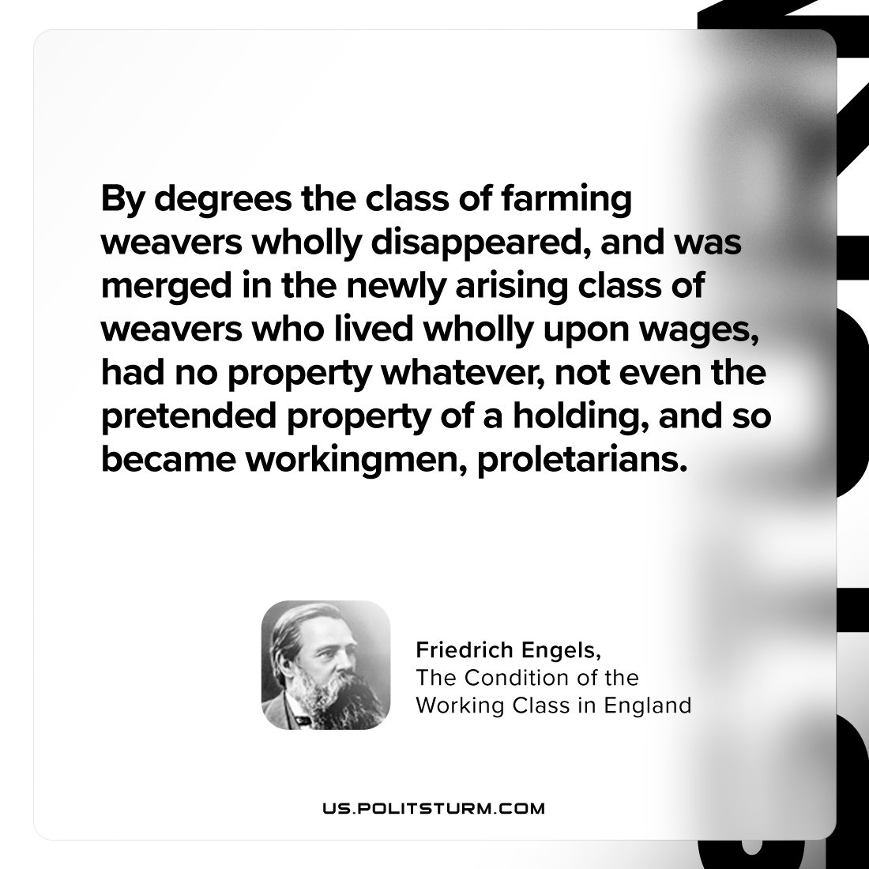

Original article
2024-02-06

"By degrees the class of farming weavers wholly disappeared, and was merged in the newly arising class of weavers who lived wholly upon wages, had no property whatever, not even the pretended property of a holding, and so became workingmen, proletarians."
Friedrich Engels, The Condition of the Working Class in England

Original article

