Engels on the Apathy Fostered by Capitalism
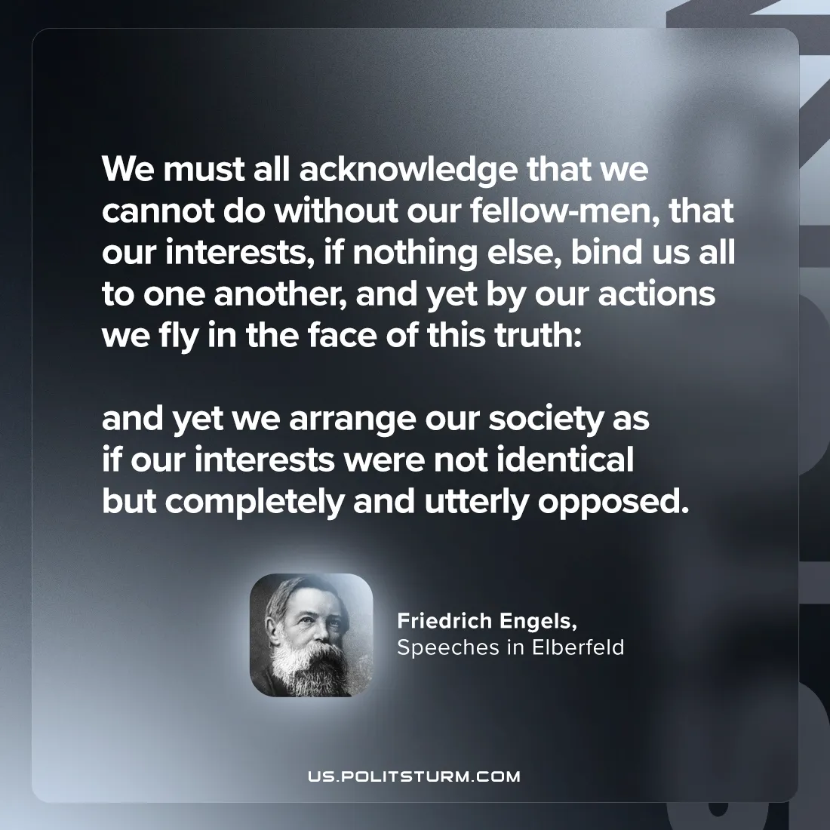

Original article
2024-09-17

“We must all acknowledge that we cannot do without our fellow-men, that our interests, if nothing else, bind us all to one another, and yet by our actions we fly in the face of this truth: and yet we arrange our society as if our interests were not identical but completely and utterly opposed.”
Friedrich Engels, Speeches in Elberfeld

Original article

