Engels on the World-View Middle Classes
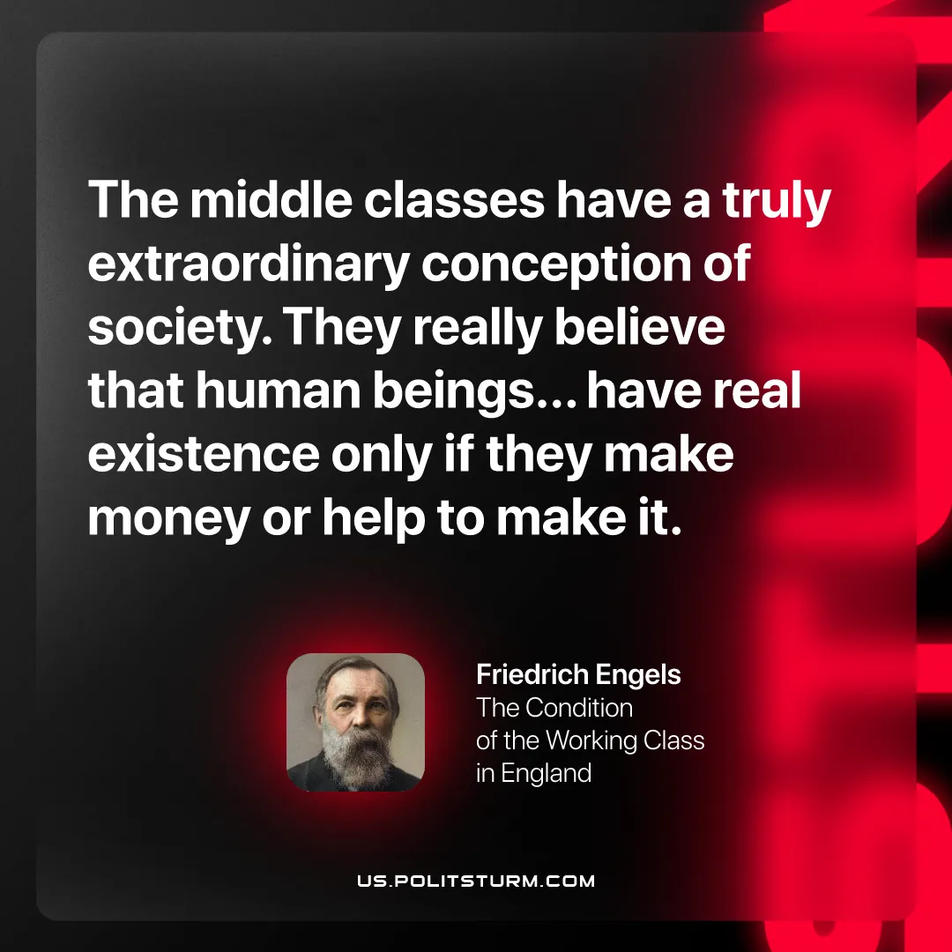

Original article
2026-04-16

“The middle classes have a truly extraordinary conception of society. They really believe that human beings . . . have real existence only if they make money or help to make it.”
Friedrich Engels, The Condition of the Working Class in England

Original article

