Engels on the Weapons of the Communists and the Present State of Things
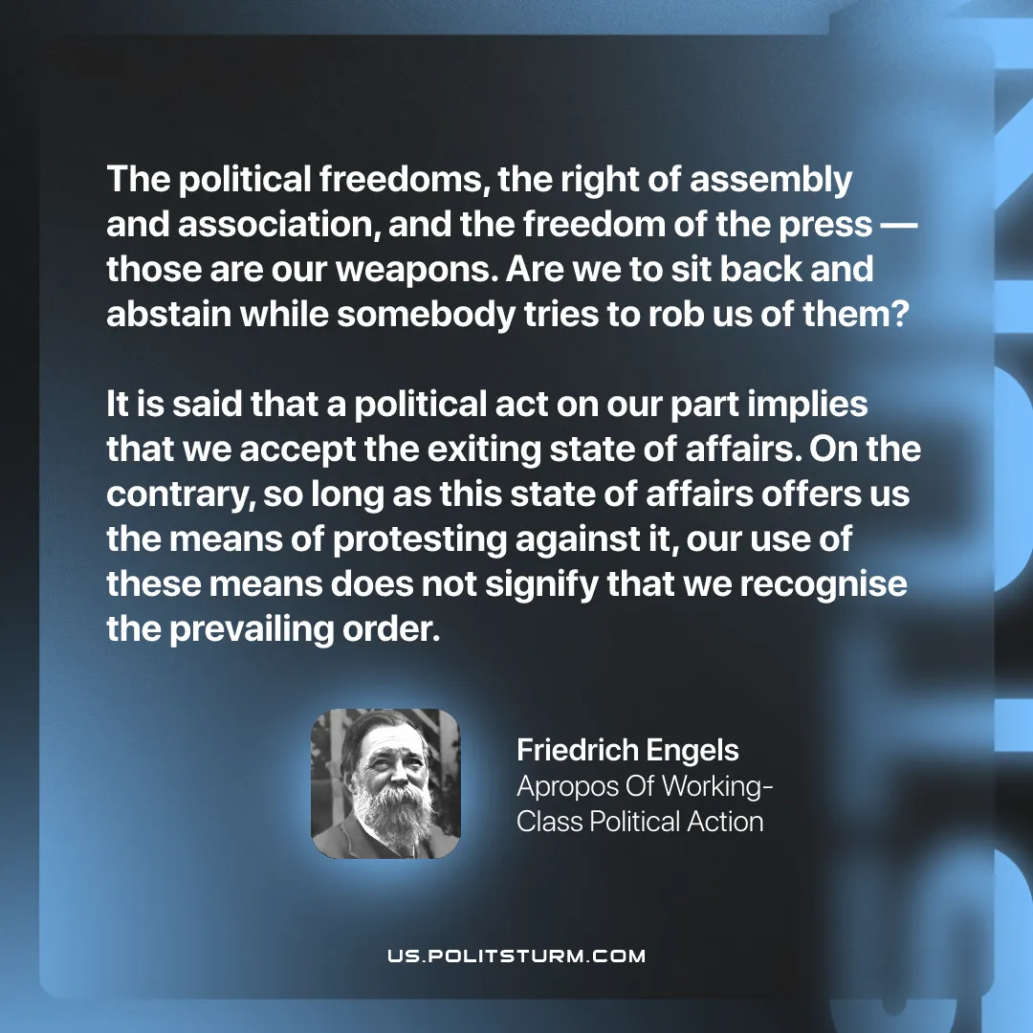

Original article
2026-04-12
1 min read

“The political freedoms, the right of assembly and association, and the freedom of the press – those are our weapons. Are we to sit back and abstain while somebody tries to rob us of them? It is said that a political act on our part implies that we accept the exiting state of affairs. On the contrary, so long as this state of affairs offers us the means of protesting against it, our use of these means does not signify that we recognise the prevailing order.”
Frederick Engels, Apropos Of Working-Class Political Action

Original article

