Engels on the Struggle of the Working Class
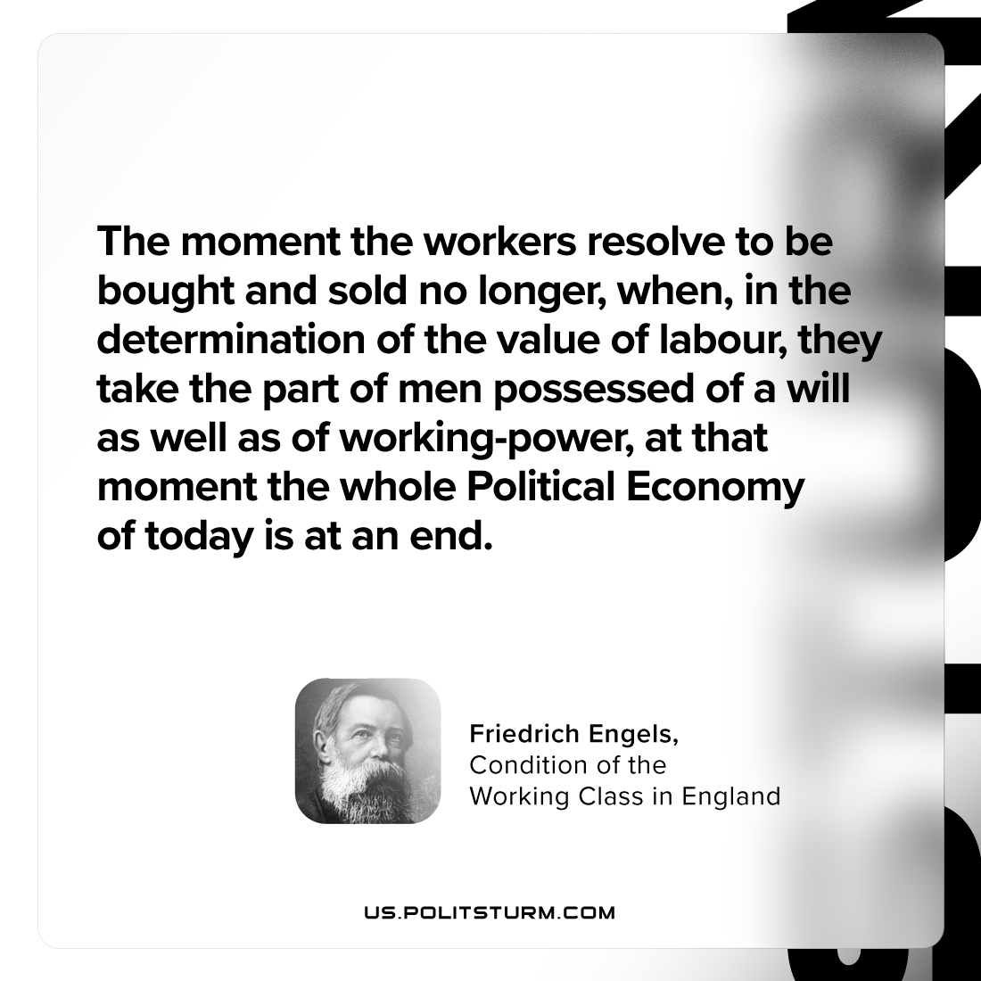

Original article
2024-03-17

“The moment the workers resolve to be bought and sold no longer, when, in the determination of the value of labour, they take the part of men possessed of a will as well as of working-power, at that moment the whole Political Economy of today is at an end.”
Friedrich Engels, Condition of the Working Class in England

Original article

