Engels on the State
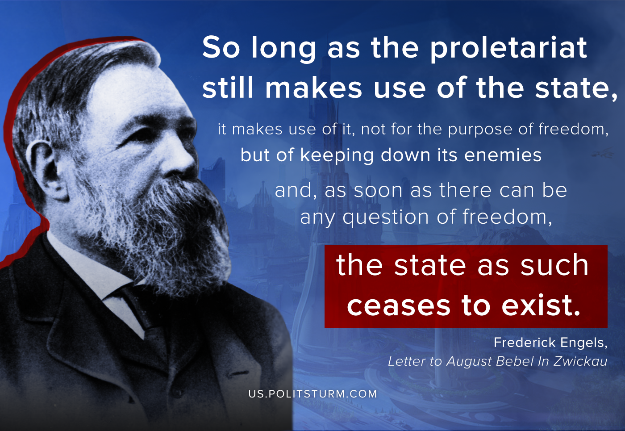

Original article
2020-07-30

So long as the proletariat still makes use of the state, it makes use of it, not for the purpose of freedom, but of keeping down its enemies and, as soon as there can be any question of freedom, the state as such ceases to exist.
F. Engels, Letter to August Bebel in Zwickau

Original article

