Engels on the Situation of Professions under Capitalism
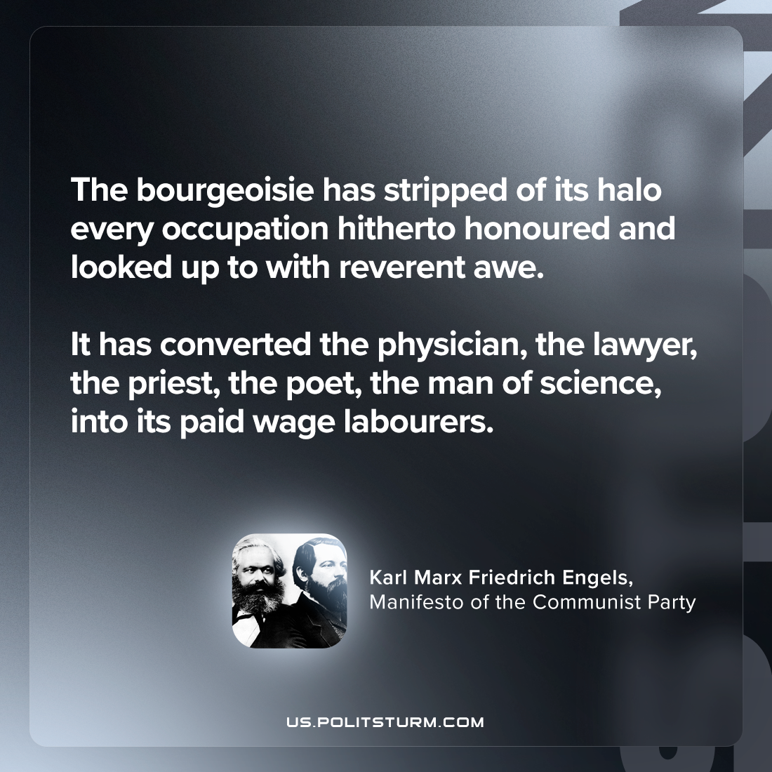

Original article
2024-04-06

“The bourgeoisie has stripped of its halo every occupation hitherto honoured and looked up to with reverent awe. It has converted the physician, the lawyer, the priest, the poet, the man of science, into its paid wage labourers.”
Karl Marx and Friedrich Engels, Manifesto of the Communist Party

Original article

