Engels on the Seizing of the Means of Production
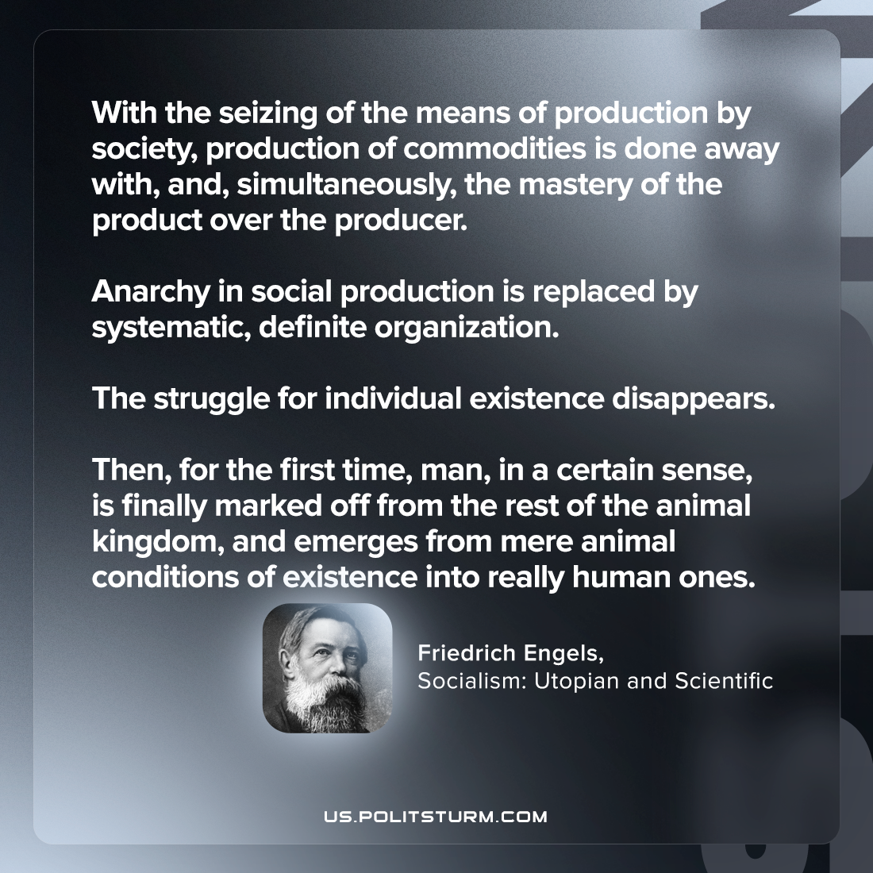

Original article
2023-06-15

"With the seizing of the means of production by society, production of commodities is done away with, and, simultaneously, the mastery of the product over the producer. Anarchy in social production is replaced by systematic, definite organization. The struggle for individual existence disappears. Then, for the first time, man, in a certain sense, is finally marked off from the rest of the animal kingdom, and emerges from mere animal conditions of existence into really human ones."
Friedrich Engels, Socialism: Utopian and Scientific

Original article

