Engels on the Proletarization of Society
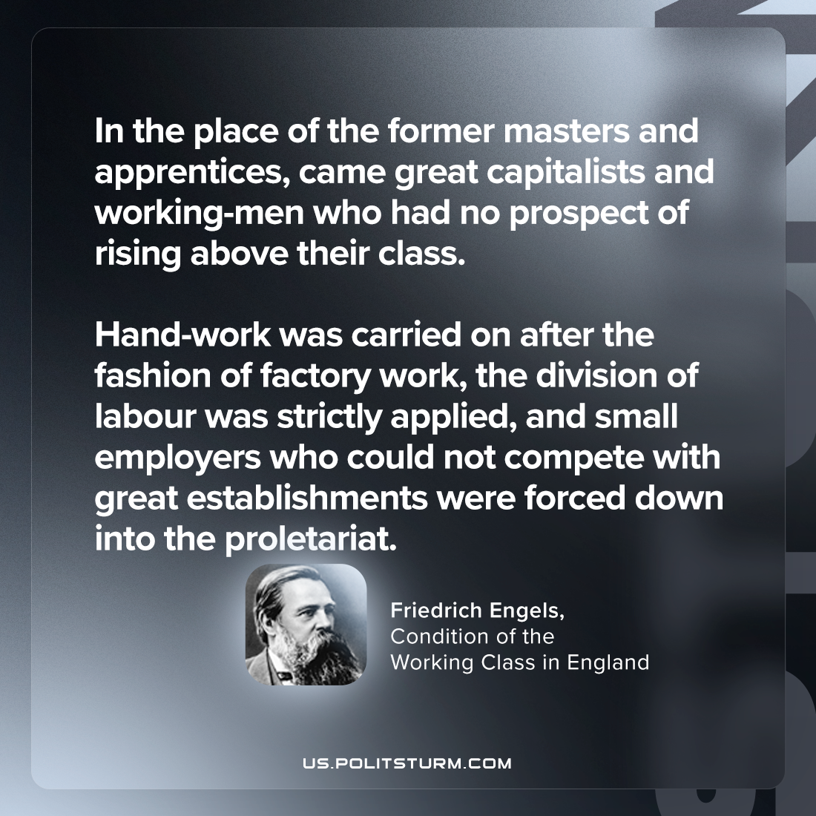

Original article
2024-04-20

“In the place of the former masters and apprentices, came great capitalists and working-men who had no prospect of rising above their class. Hand-work was carried on after the fashion of factory work, the division of labour was strictly applied, and small employers who could not compete with great establishments were forced down into the proletariat.”
Friedrich Engels, Condition of the Working Class in England

Original article

