Engels on the Peasant War and Class Struggle
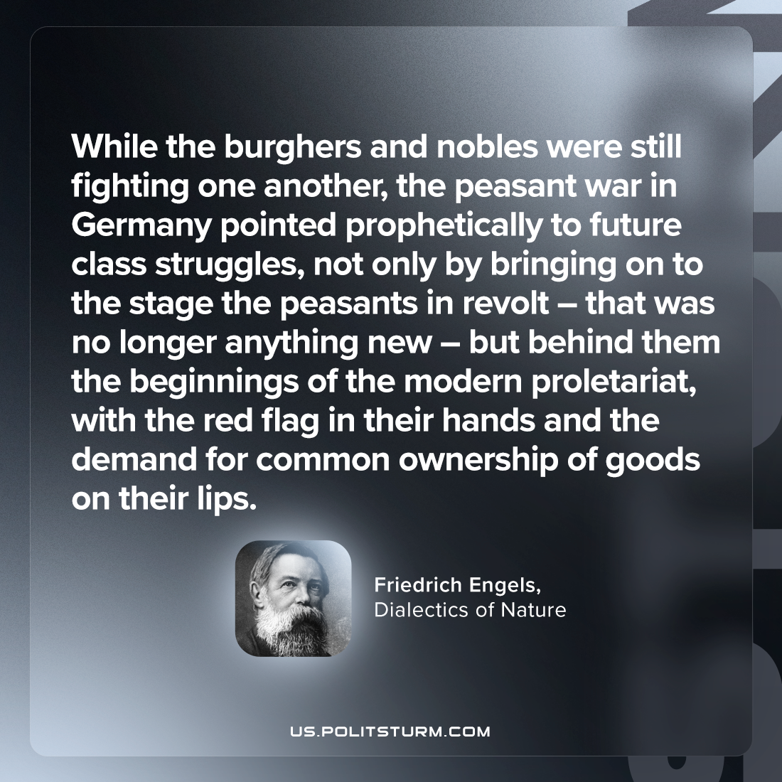

Original article
2023-12-03

"While the burghers and nobles were still fighting one another, the peasant war in Germany pointed prophetically to future class struggles, not only by bringing on to the stage the peasants in revolt – that was no longer anything new – but behind them the beginnings of the modern proletariat, with the red flag in their hands and the demand for common ownership of goods on their lips."
Friedrich Engels, Dialectics of Nature

Original article

