Engels on the Origin of Capitalist Class Struggle
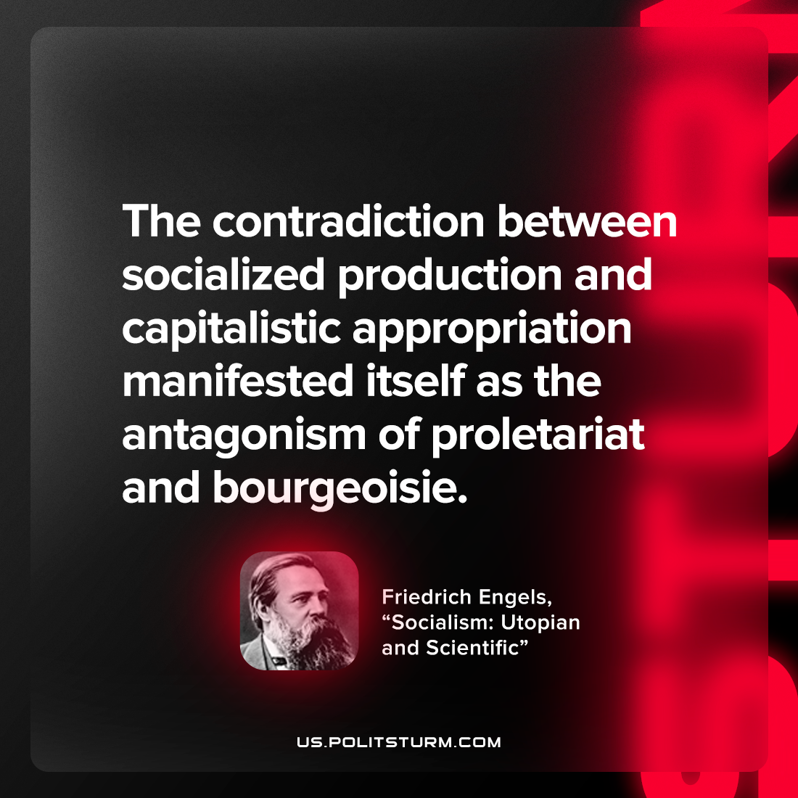

Original article
2022-11-13

The contradiction between socialized production and capitalistic appropriation manifested itself as the antagonism of proletariat and bourgeoisie.

Frederich Engels, “Socialism: Utopian and Scientific”

Original article

