Engels on the Modern Society
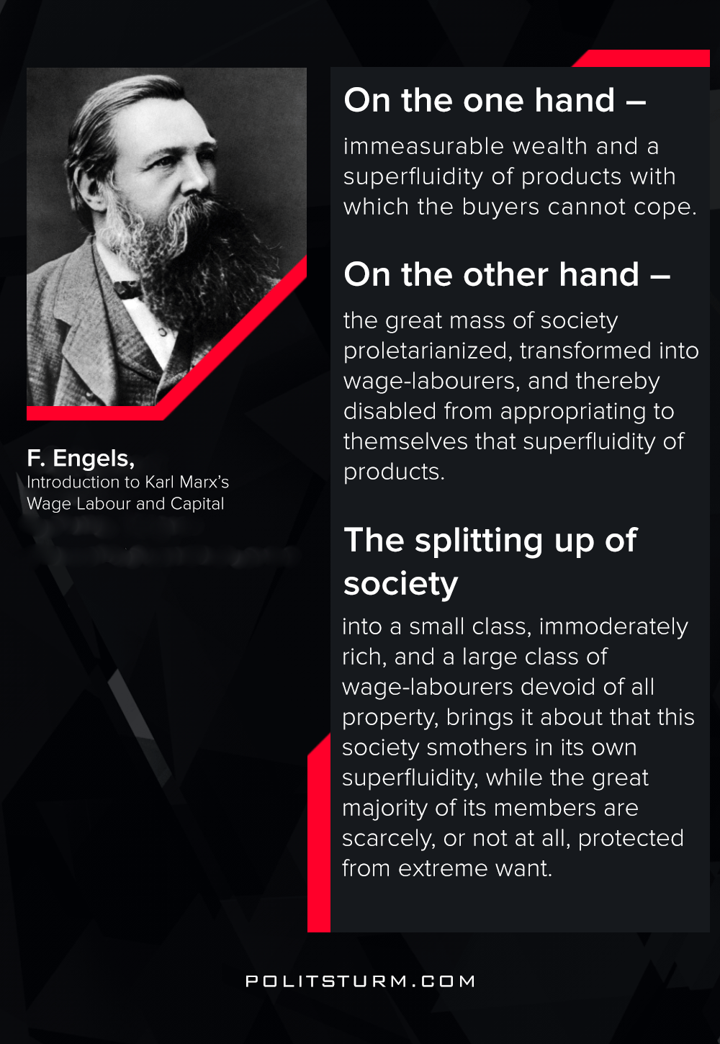

Original article
2020-11-28
1 min read

On the one hand, immeasurable wealth and a superfluidity of products with which the buyers cannot cope.
On the other hand, the great mass of society proletarianized, transformed into wage-labourers, and thereby disabled from appropriating to themselves that superfluidity of products.
The splitting up of society into a small class, immoderately rich, and a large class of wage-labourers devoid of all property, brings it about that this society smothers in its own superfluidity, while the great majority of its members are scarcely, or not at all, protected from extreme want.
Friedrich Engels, Introduction to Karl Marx’s Wage Labour and Capital

Original article

