Engels on the Importance of Unions and Strikes
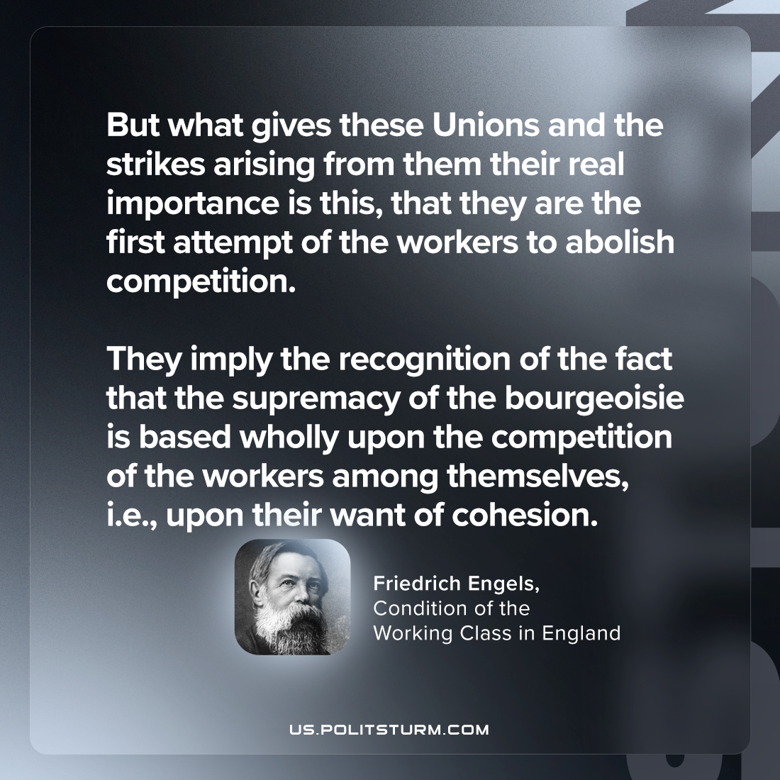

Original article
2024-05-25

"But what gives these Unions and the strikes arising from them their real importance is this, that they are the first attempt of the workers to abolish competition. They imply the recognition of the fact that the supremacy of the bourgeoisie is based wholly upon the competition of the workers among themselves; i.e., upon their want of cohesion."
Friedrich Engels, The Condition of the Working class in England

Original article

