Engels on The Hypocrisy of The Rich
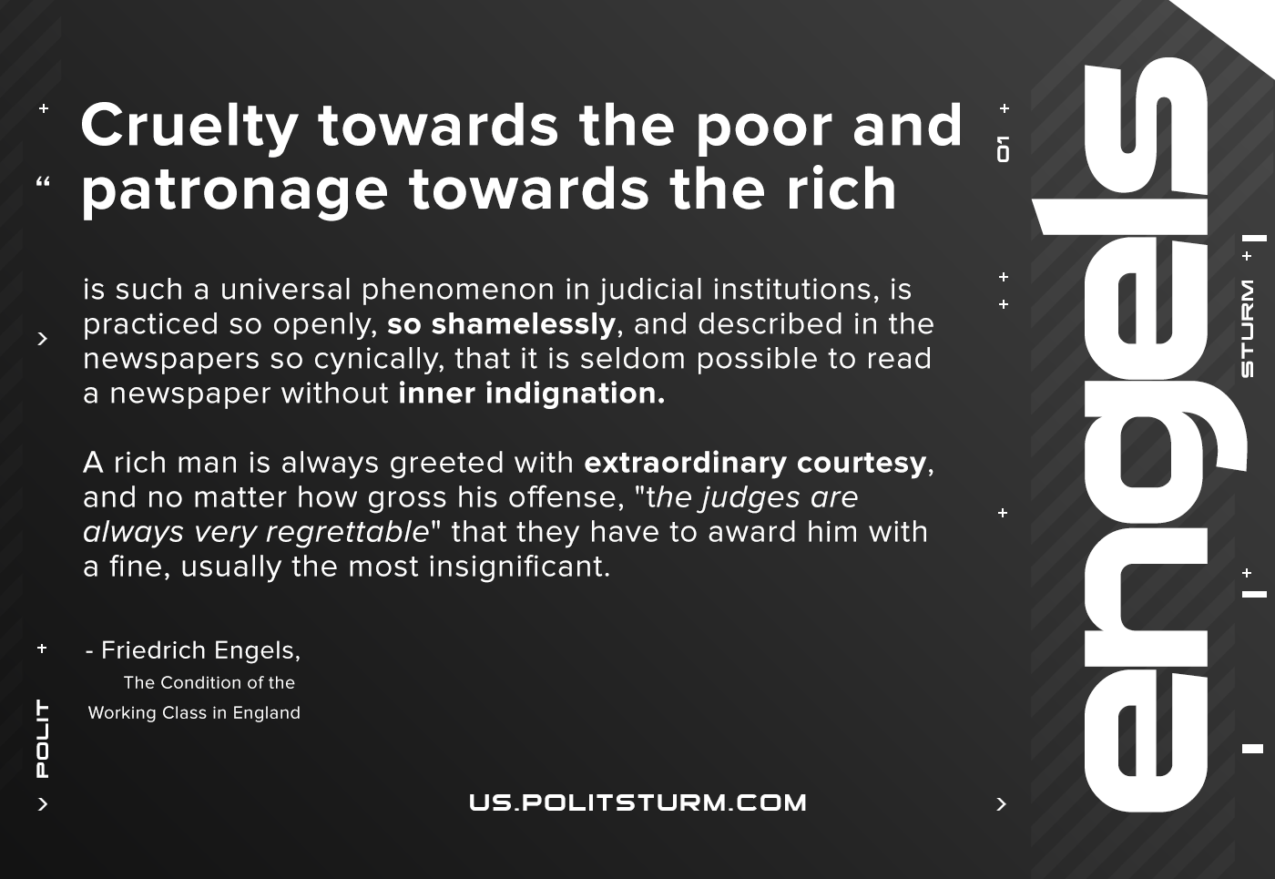

Original article
2020-12-01
1 min read

Cruelty towards the poor and patronage towards the rich is such a universal phenomenon in all judicial institutions, is practiced so openly, so shamelessly and described in the newspapers so cynically that it is rarely possible to read a newspaper without inner indignation.
A rich man is always greeted with extraordinary courtesy, and no matter how gross his offense, “the judges are always very regrettable” that they have to award him with a fine, usually the most insignificant.
F.Engels, The Condition of England.

Original article

