Engels on the Goals of Socialism
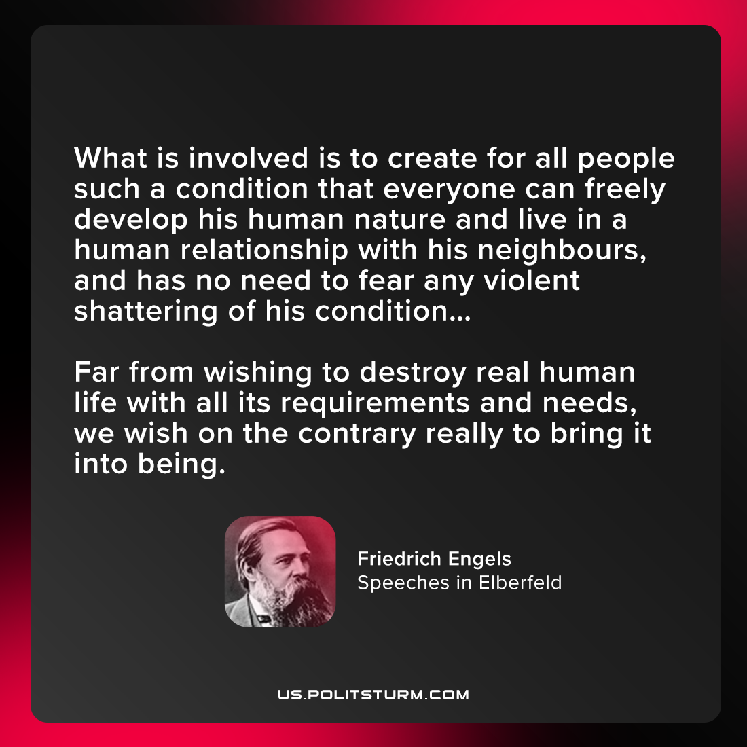

Original article
2021-07-26

What is involved is to create for all people such a condition that everyone can freely develop his human nature and live in a human relationship with his neighbours, and has no need to fear any violent shattering of his condition… Far from wishing to destroy real human life with all its requirements and needs, we wish on the contrary really to bring it into being.

Friedrich Engels, “Speeches in Elberfeld”

Original article

