Engels on the Difference between the Interests of the Worker and the Bourgeois
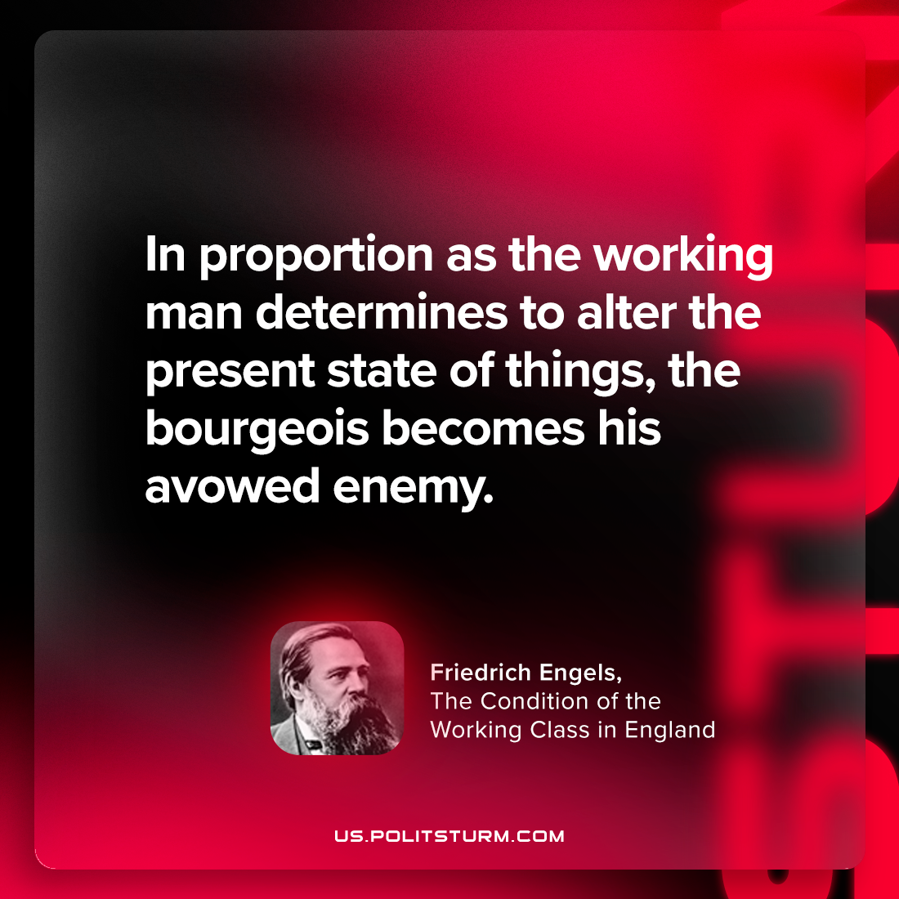

Original article
2023-12-07

"In proportion as the working-man determines to alter the present state of things, the bourgeois becomes his avowed enemy."
Friedrich Engels, The Condition of the Working Class in England

Original article

