Engels on the Development of Monopoly and its Consequences
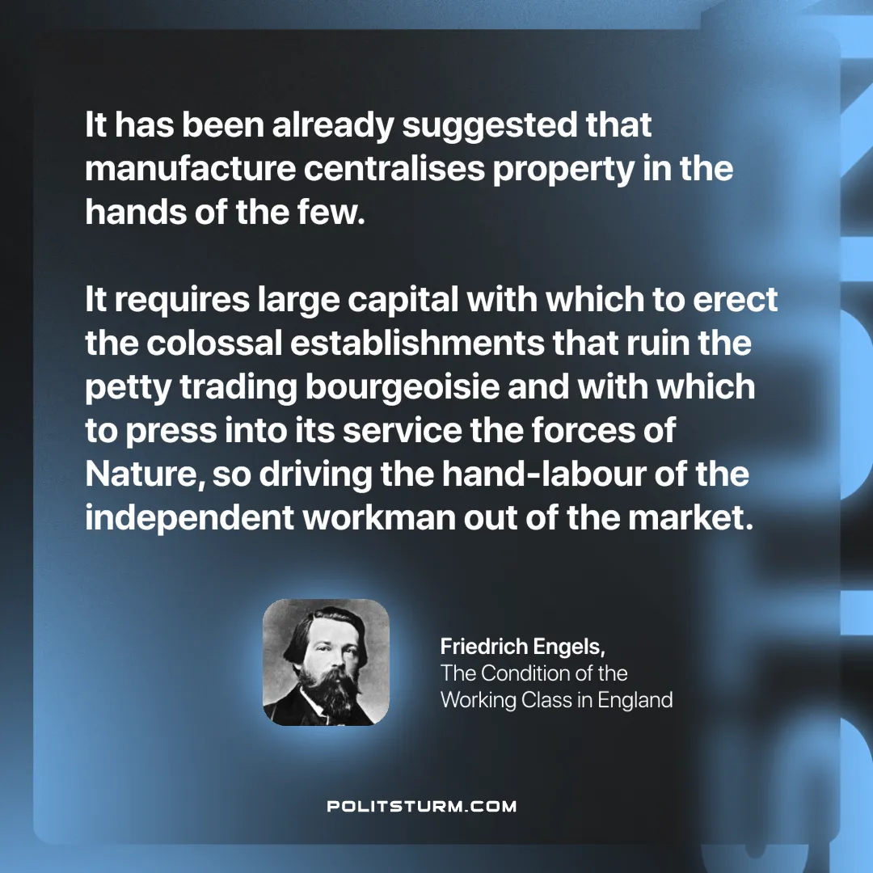

Original article
2025-02-09

“It has been already suggested that manufacture centralises property in the hands of the few. It requires large capital with which to erect the colossal establishments that ruin the petty trading bourgeoisie and with which to press into its service the forces of Nature, so driving the hand-labour of the independent workman out of the market.”
Friedrich Engels, The Condition of the Working Class in England

Original article

