Engels on the Destruction of Classes
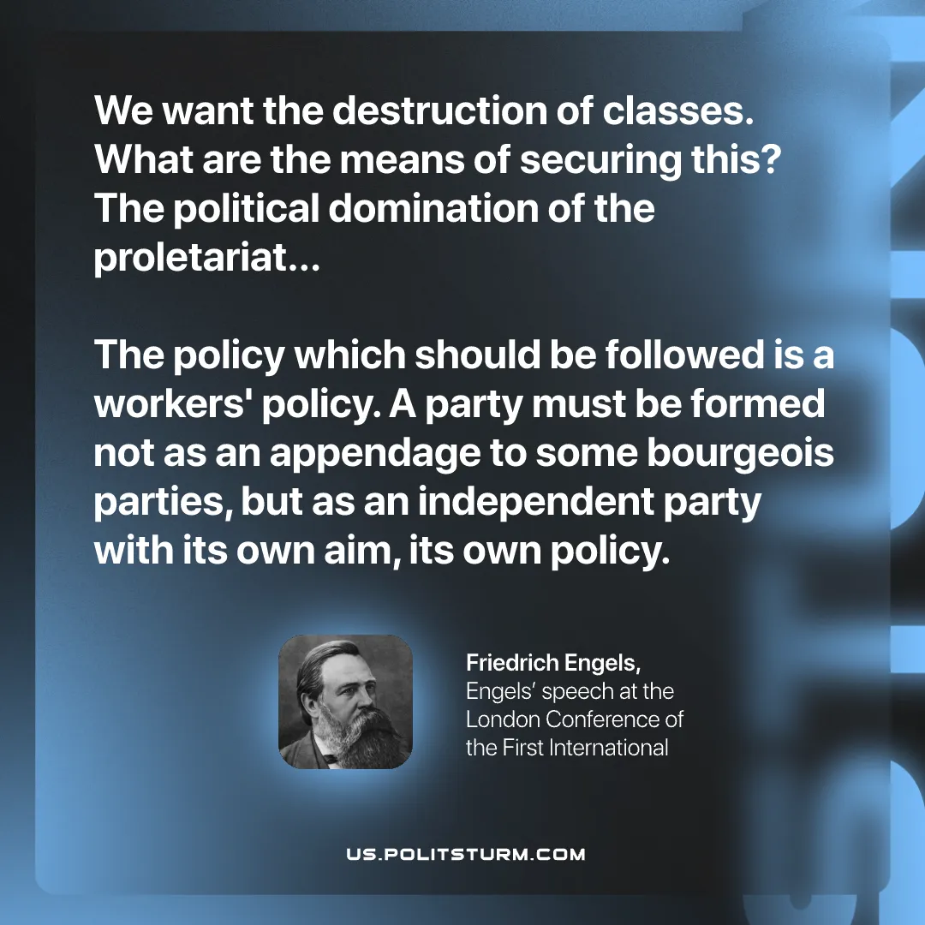

Original article
2026-08-13

We want the destruction of classes. What are the means of securing this? The political domination of the proletariat... The policy which should be followed is a workers' policy. A party must be formed not as an appendage to some bourgeois parties, but as an independent party with its own aim, its own policy."
Friedrich Engels, Engels' speech at the London Conference of the First International

Original article

