Engels on the Deprivation of the Workers
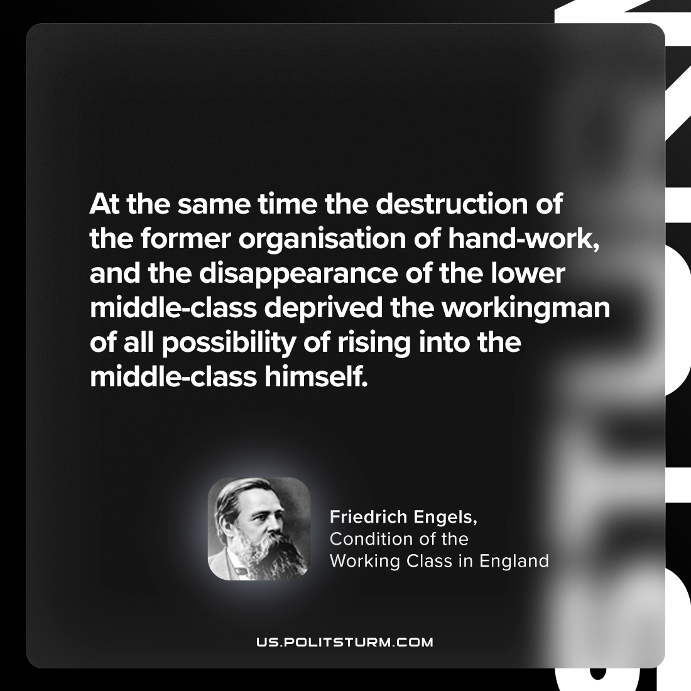

Original article
2024-06-02

"At the same time the destruction of the former organisation of hand-work, and the disappearance of the lower middle-class deprived the workingman of all possibility of rising into the middle-class himself."
Friedrich Engels, The Condition of the Working Class in England

Original article

