Engels on the Contradictions on Labour and Capital
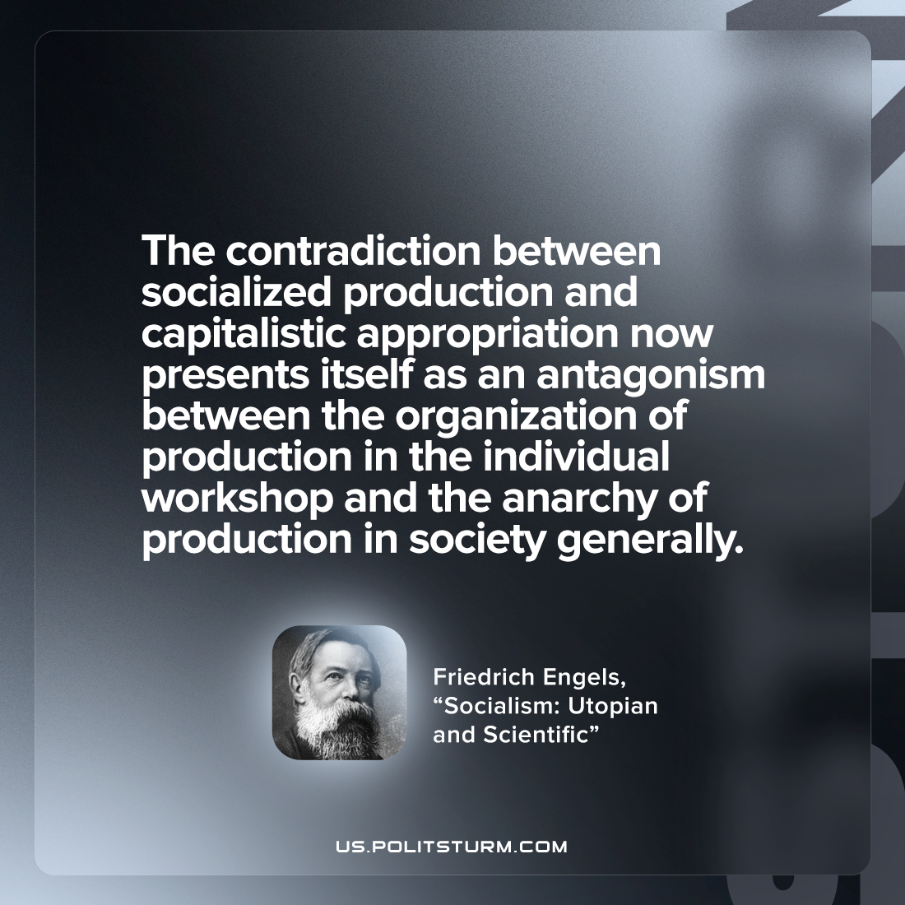

Original article
2022-10-08

The contradiction between socialized production and capitalistic appropriation now presents itself as an antagonism between the organization of production in the individual workshop and the anarchy of production in society generally.

Friedrich Engels, “Socialism: Utopian and Scientific”

Original article

