Engels on the Competition of Workers
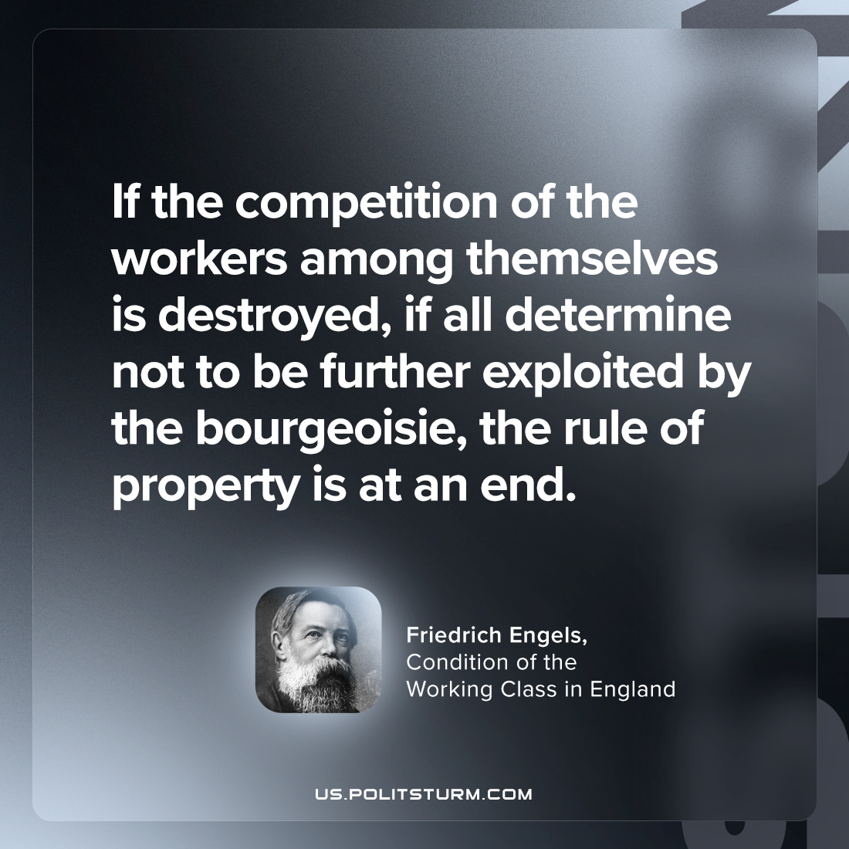

Original article
2024-02-27

"If the competition of the workers among themselves is destroyed, if all determine not to be further exploited by the bourgeoisie, the rule of property is at an end. "
Friedrich Engels, The Condition of the Working Class in England

Original article

