Engels on the Class Struggle against the Bourgeoisie
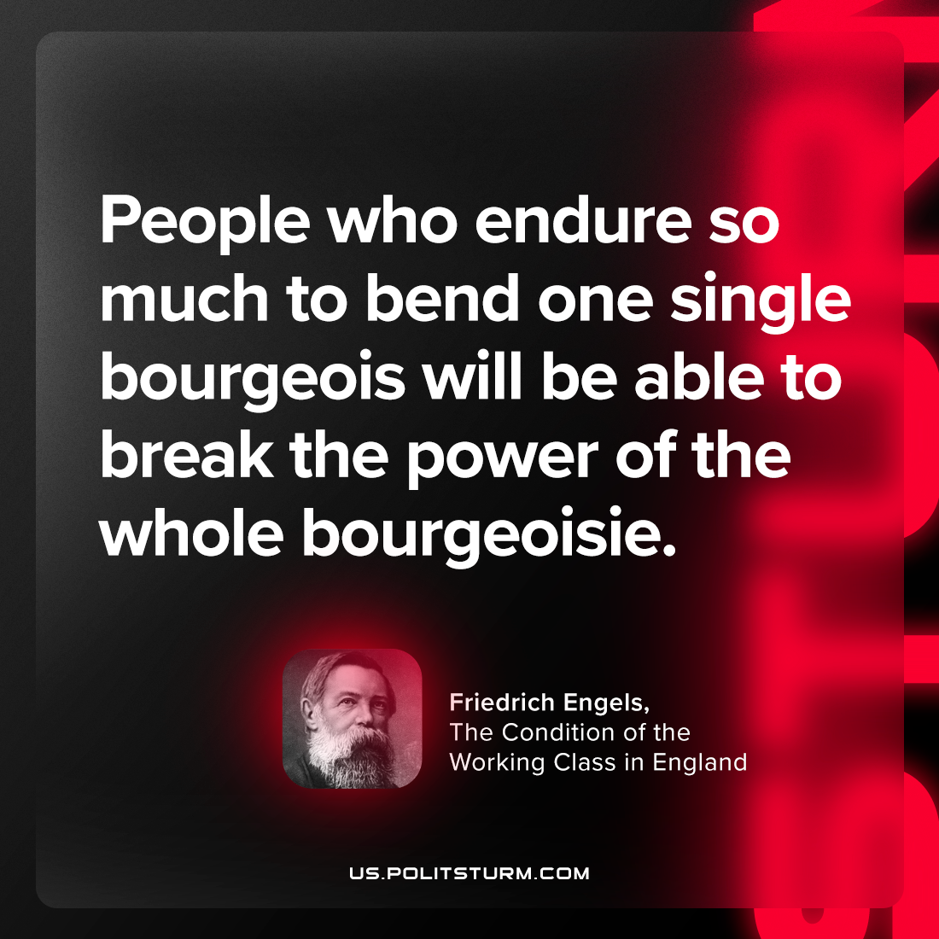

Original article
2023-12-05

"People who endure so much to bend one single bourgeois will be able to break the power of the whole bourgeoisie."
Friedrich Engels, The Condition of the Working Class in England

Original article

