Engels on the Capitalist and the Law
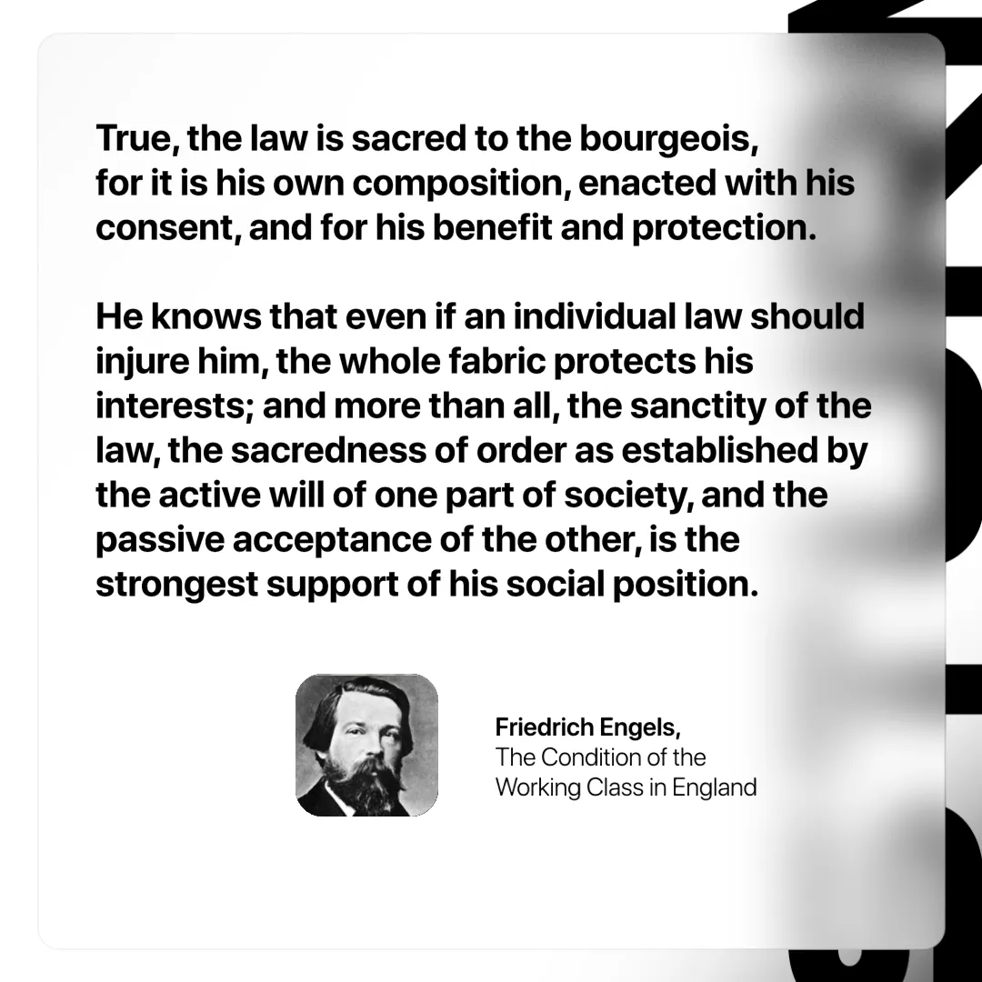

Original article
2025-01-02
1 min read

“True, the law is sacred to the bourgeois, for it is his own composition, enacted with his consent, and for his benefit and protection. He knows that, even if an individual law should injure him, the whole fabric protects his interests; and more than all, the sanctity of the law, the sacredness of order as established by the active will of one part of society, and the passive acceptance of the other, is the strongest support of his social position.”
Friedrich Engels, The Condition of the Working Class in England

Original article

