Engels on the Attitude of the Rich Towards the Poor
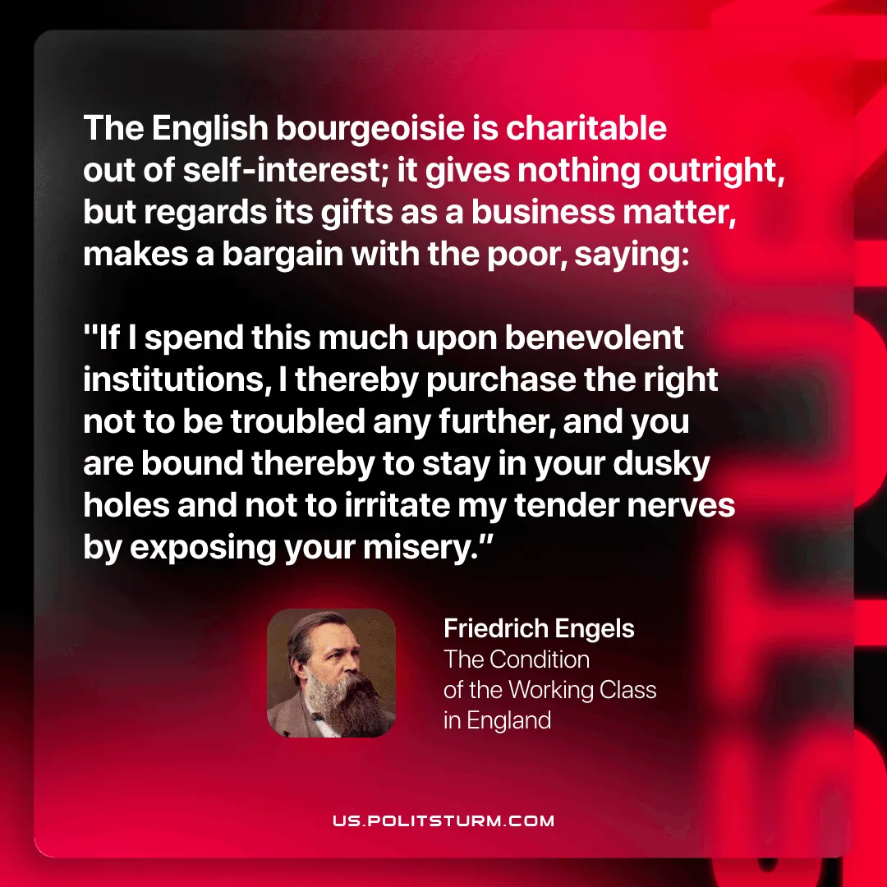

Original article
2026-04-14

“The English bourgeoisie is charitable out of self-interest; it gives nothing outright, but regards its gifts as a business matter, makes a bargain with the poor, saying: "If I spend this much upon benevolent institutions, I thereby purchase the right not to be troubled any further, and you are bound thereby to stay in your dusky holes and not to irritate my tender nerves by exposing your misery.”
Friedrich Engels, The Condition of the Working Class in England

Original article

