Engels on the Abolition of Competition
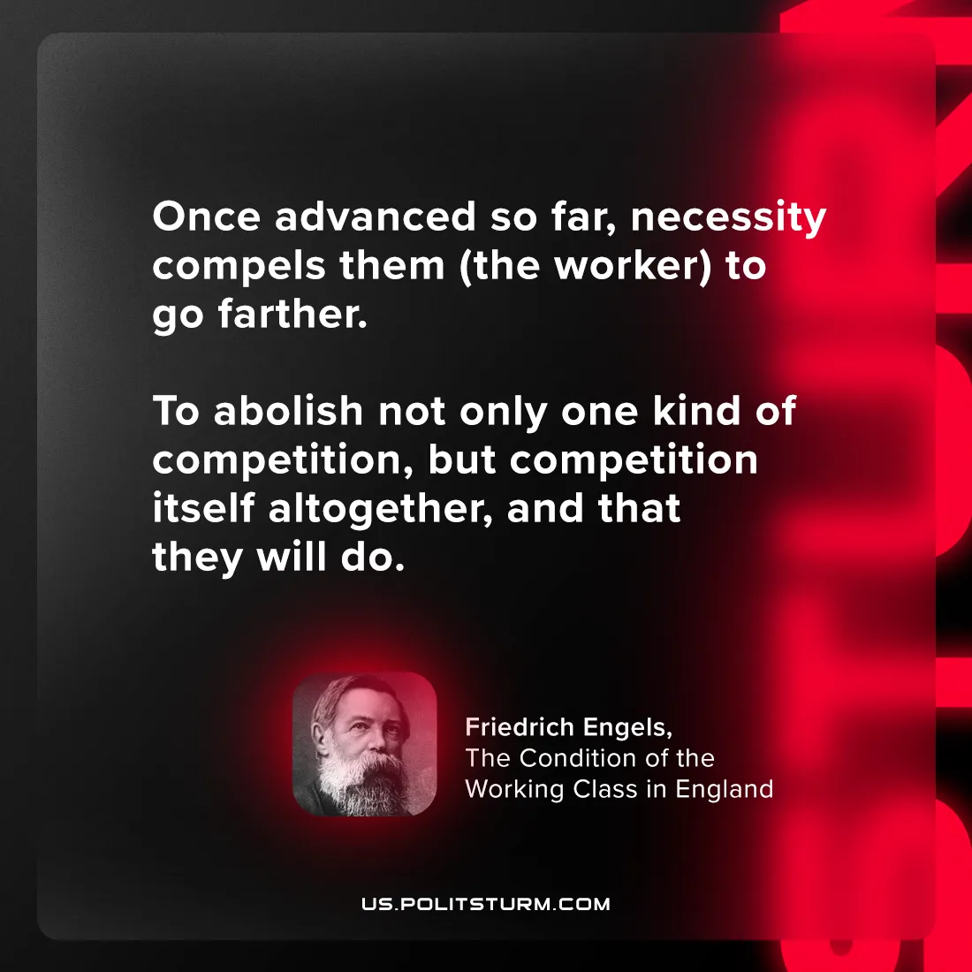

Original article
2024-07-18

"Once advanced so far, necessity compels them to go farther; to abolish not only one kind of competition, but competition itself altogether, and that they will do."
Friedrich Engels, The Condition of the Working Class in England

Original article

