Engels on Surplus-Labour and Capital
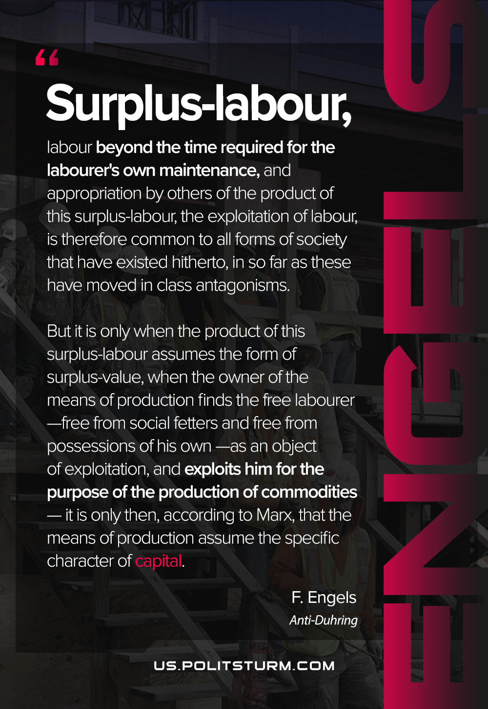

Original article
2021-05-11
1 min read

Surplus-labour, labour beyond the time required for the labourer’s own maintenance, and appropriation by others of the product of this surplus-labour, the exploitation of labour, is therefore common to all forms of society that have existed hitherto, in so far as these have moved in class antagonisms. But it is only when the product of this surplus-labour assumes the form of surplus-value, when the owner of the means of production finds the free labourer—free from social fetters and free from possessions of his own—as an object of exploitation, and exploits him for the purpose of the production of commodities—it is only then, according to Marx, that the means of production assume the specific character of capital.
Anti-Dühring

Original article

