Engels on State-Ownership
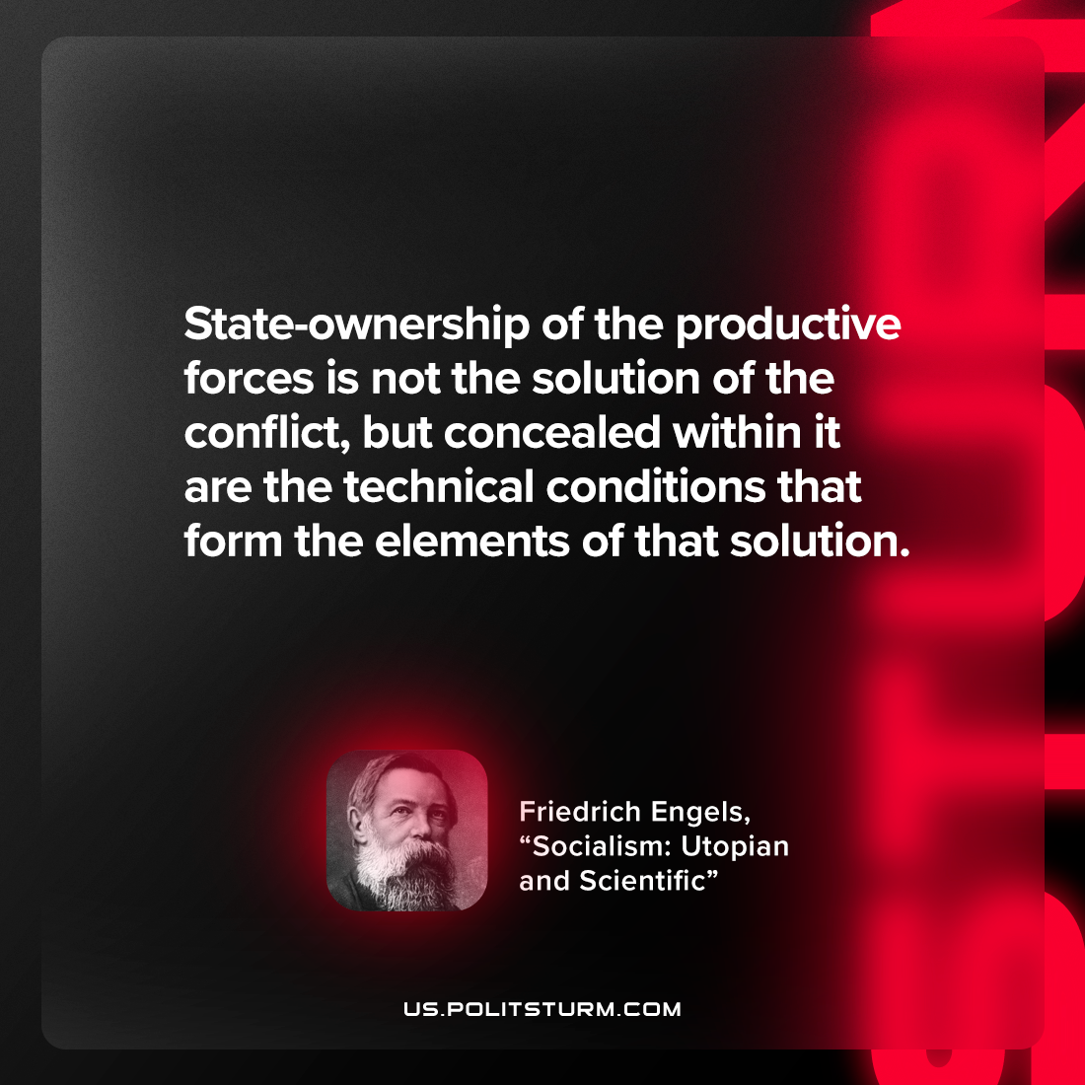

Original article
2022-12-25

"State-ownership of the productive forces is not the solution of the conflict, but concealed within it are the technical conditions that form the elements of that solution"
Friedrich Engels, “Socialism: Utopian and Scientific”

Original article

