Engels on Public Property
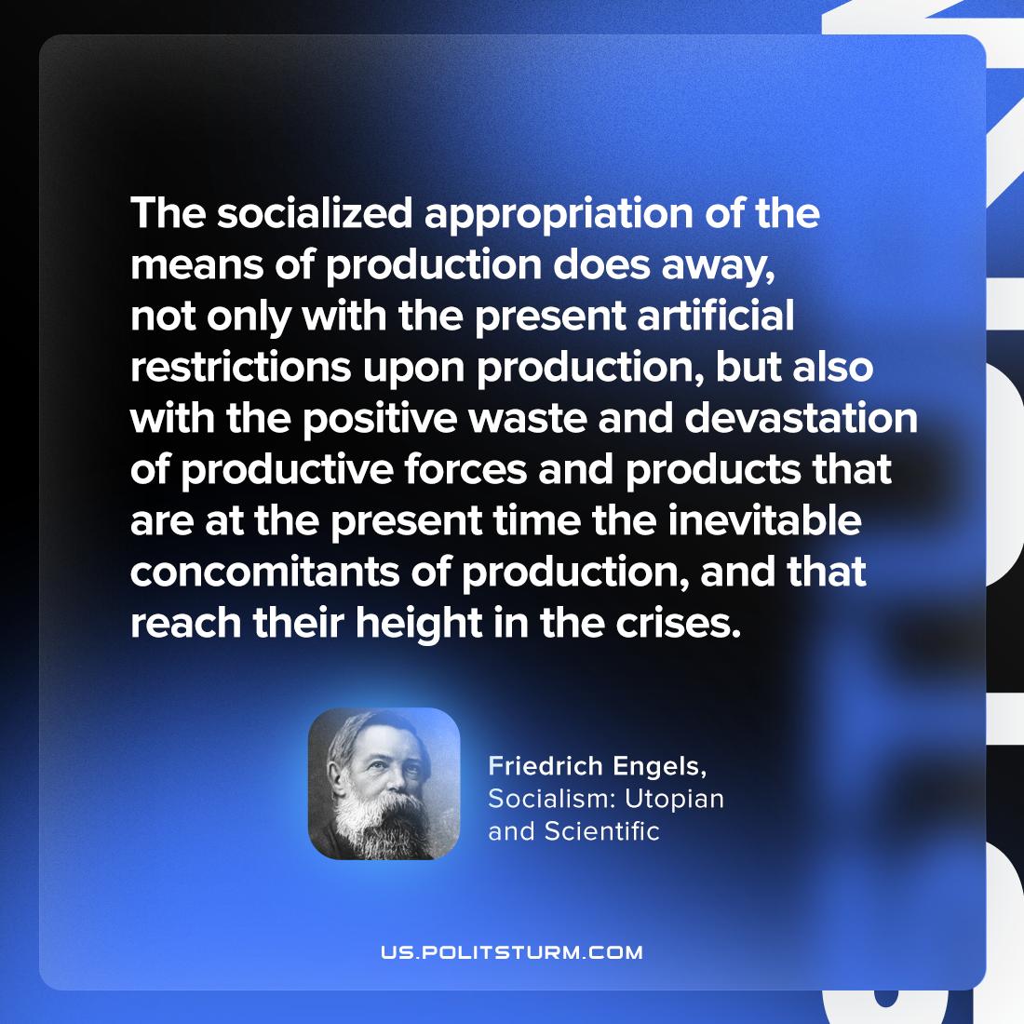

Original article
2023-05-27

"The socialized appropriation of the means of production does away, not only with the present artificial restrictions upon production, but also with the positive waste and devastation of productive forces and products that are at the present time the inevitable concomitants of production, and that reach their height in the crises."
Friedrich Engels, “Socialism: Utopian and Scientific”

Original article

