Engels on Production Evolving
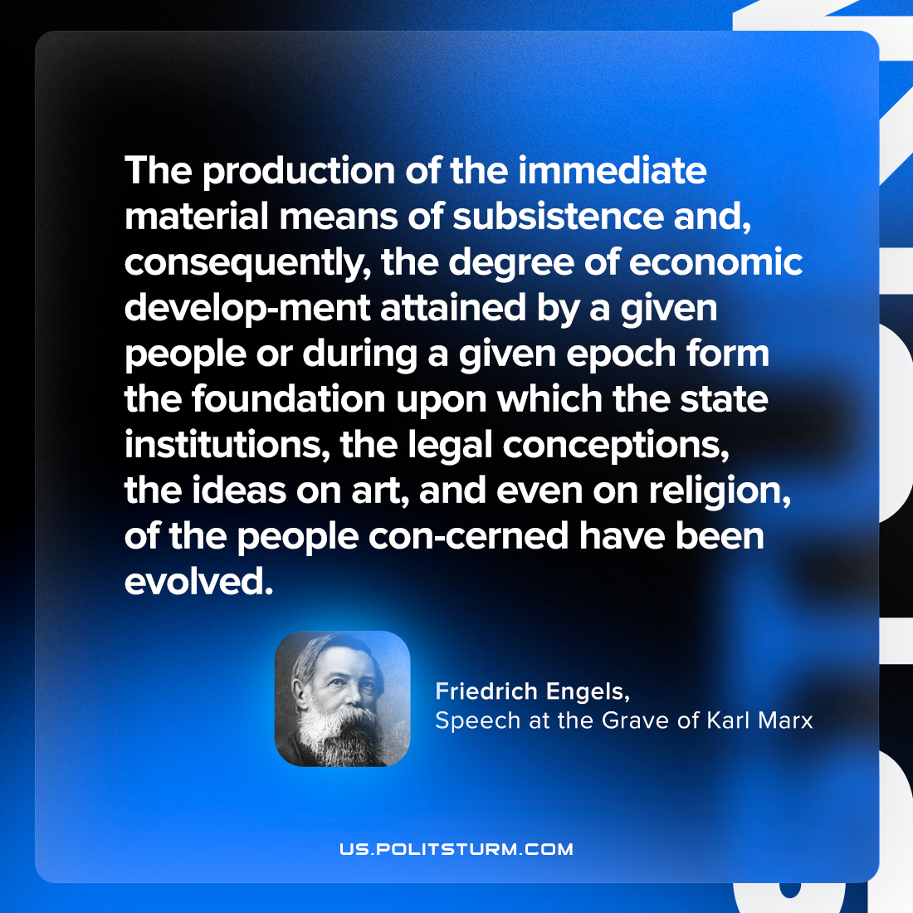

Original article
2023-06-13

"The production of the immediate material means of subsistence and, consequently, the degree of economic develop-ment attained by a given people or during a given epoch form the foundation upon which the state institutions, the legal conceptions, the ideas on art, and even on religion, of the people con-cerned have been evolved."
Friedrich Engels, Speech at the Grave of Karl Marx

Original article

