Engels on Perception and Circumstances
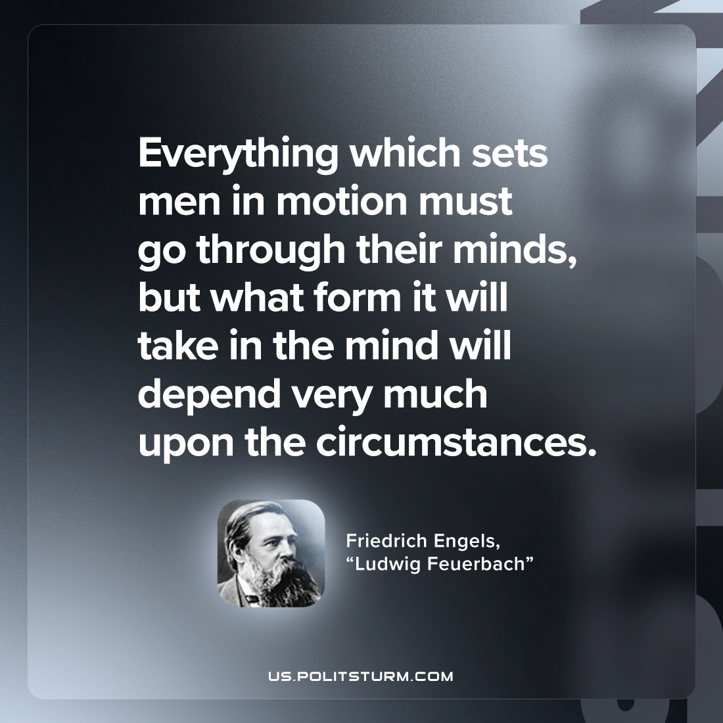

Original article
2023-03-19

"Everything which sets men in motion must go through their minds, but what form it will take in the mind will depend very much upon the circumstances."
Friedrich Engels, "Ludwig Feuerbach"

Original article

