Engels on National Capitalism
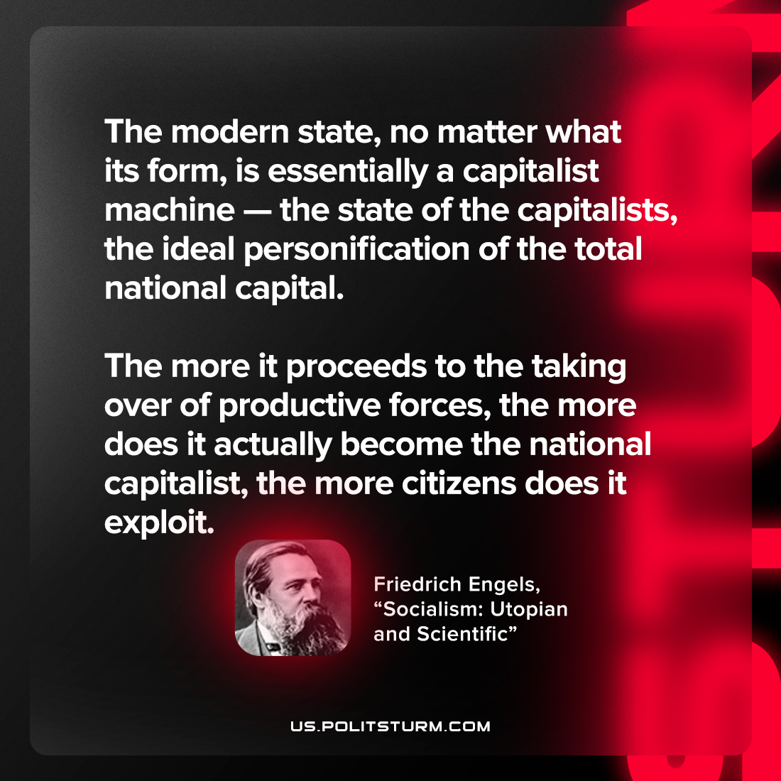

Original article
2023-01-31

"The modern state, no matter what its form, is essentially a capitalist machine — the state of the capitalists, the ideal personification of the total national capital. The more it proceeds to the taking over of productive forces, the more does it actually become the national capitalist, the more citizens does it exploit."
Friedrich Engels, “Socialism: Utopian and Scientific”

Original article

