Engels on Modes of Production
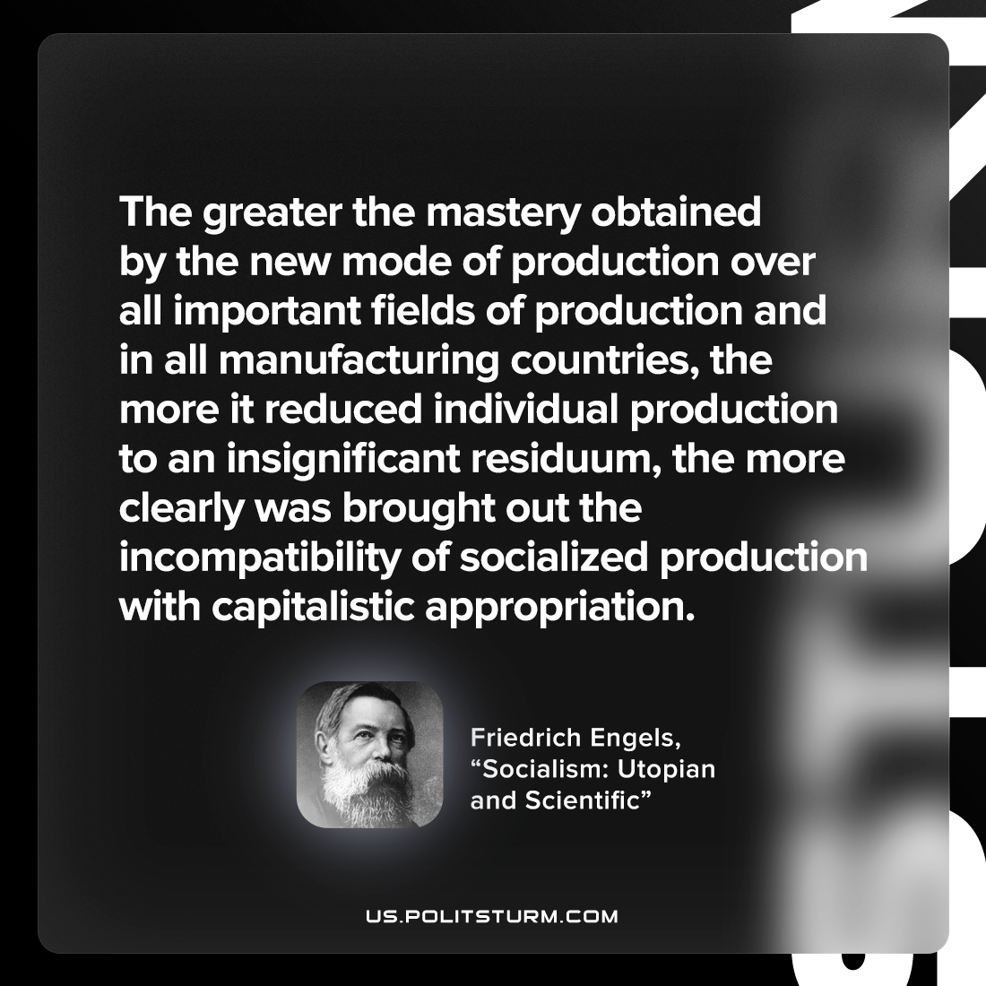

Original article
2022-11-07

The greater the mastery obtained by the new mode of production over all important fields of production and in all manufacturing countries, the more it reduced individual production to an insignificant residuum, the more clearly was brought out the incompatibility of socialized production with capitalistic appropriation.

Friedrich Engels, “Socialism: Utopian and Scientific”

Original article

