Engels on Market and Planned Economy
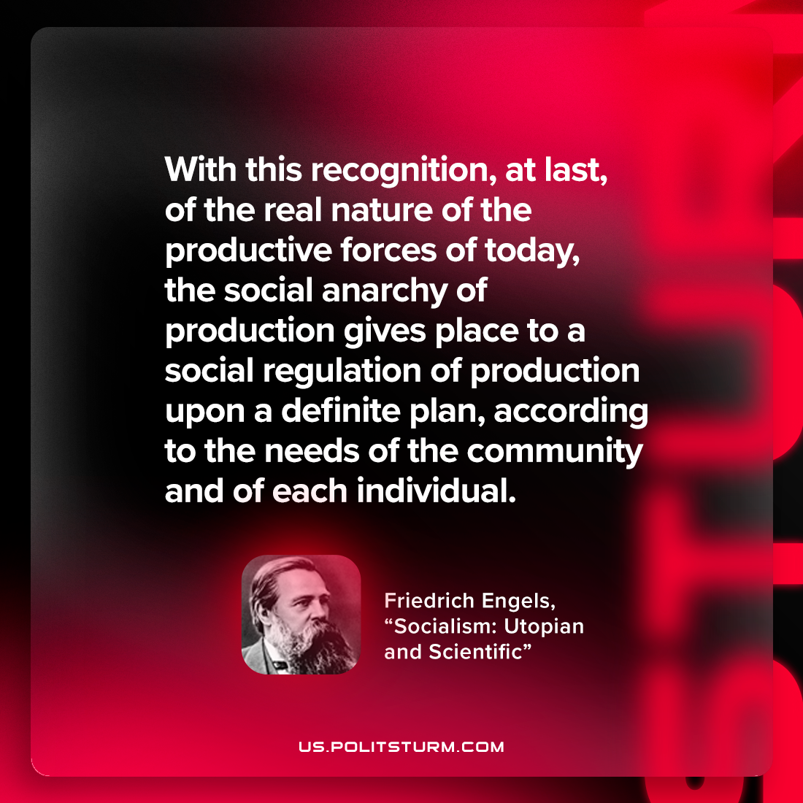

Original article
2022-12-18

"With this recognition, at last, of the real nature of the productive forces of today, the social anarchy of production gives place to a social regulation of production upon a definite plan, according to the needs of the community and of each individual."
Friedrich Engels, “Socialism: Utopian and Scientific”

Original article

