Engels on Manufacture Drawing Together the Interests of Mankind
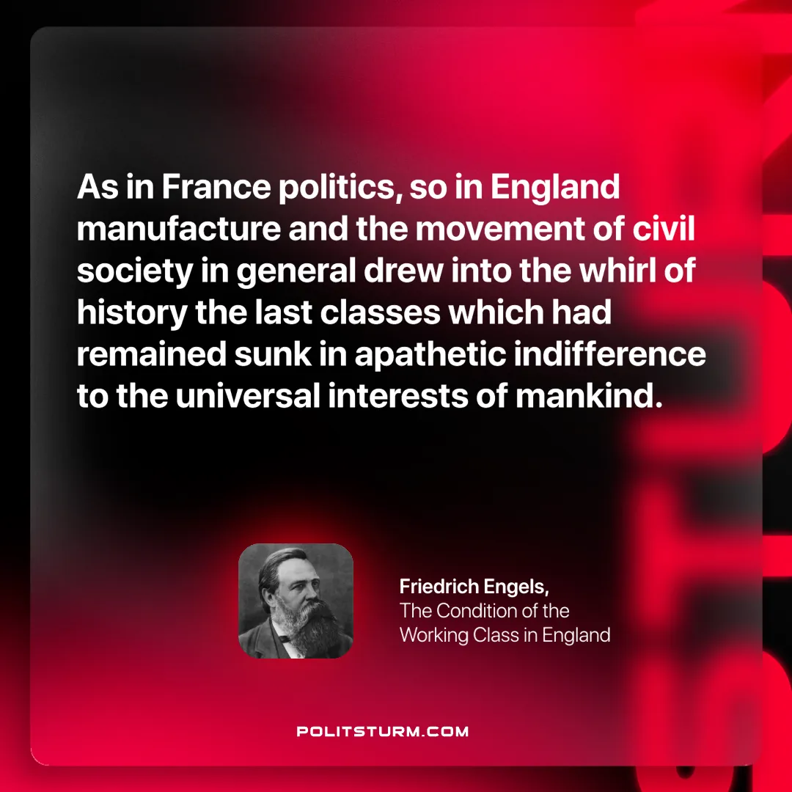

Original article
2025-02-08

“As in France politics, so in England manufacture and the movement of civil society in general drew into the whirl of history the last classes which had remained sunk in apathetic indifference to the universal interests of mankind.”
Friedrich Engels, The Condition of the Working Class in England

Original article

