Engels on Industry
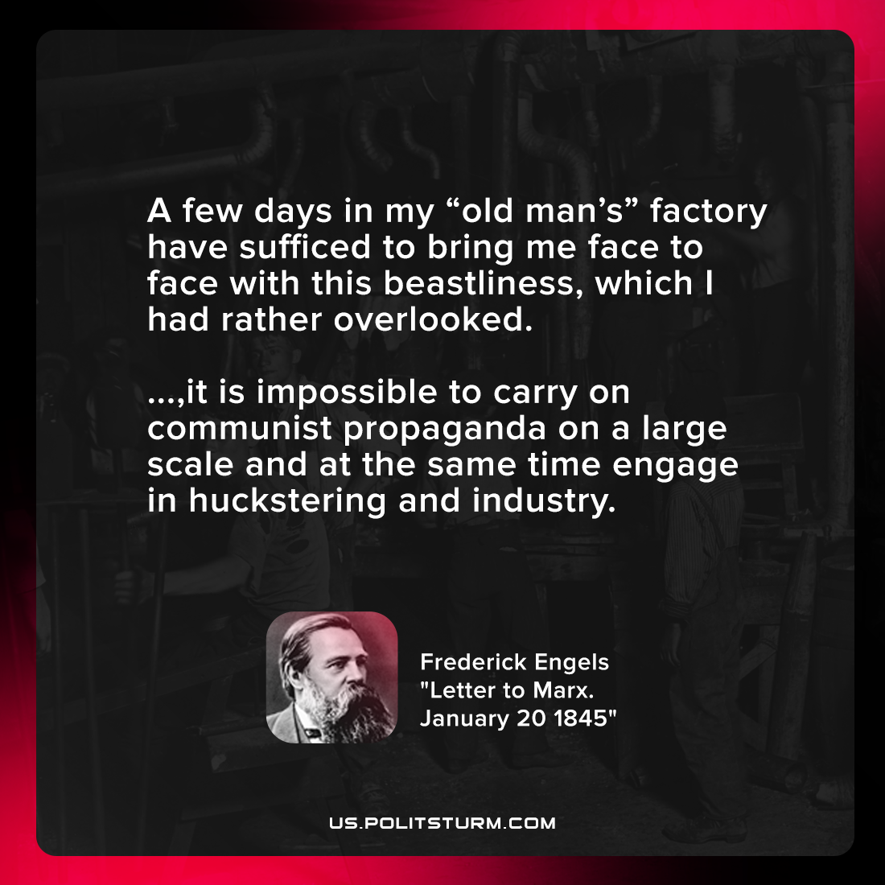

Original article
2021-11-13

A few days in my “old man’s” factory have sufficed to bring me face to face with this beastliness, which I had rather overlooked. …, it is impossible to carry on communist propaganda on a large scale and at the same time engage in huckstering and industry.

Frederick Engels, “Letter to Marx. January 20 1845”

Original article

