Engels on 'Honest' Opportunists
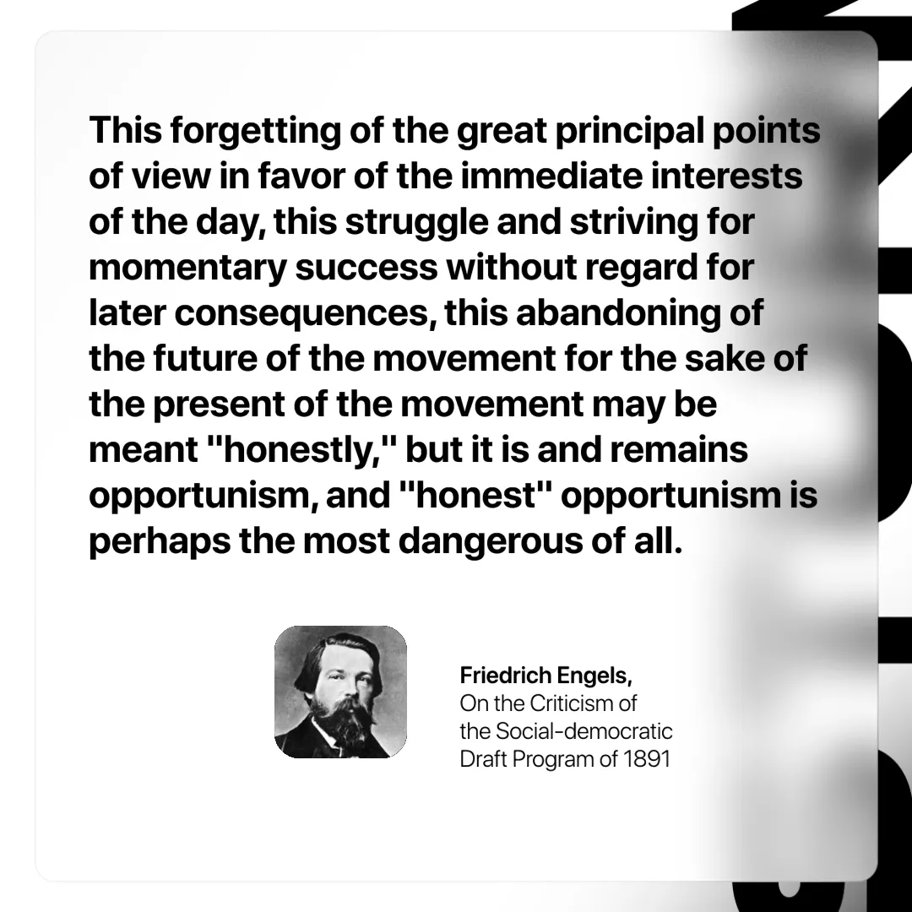

Original article
2025-05-10

“This forgetting of the great principal points of view in favor of the immediate interests of the day, this struggle and striving for momentary success without regard for later consequences, this abandoning of the future of the movement for the sake of the present of the movement may be meant "honestly," but it is and remains opportunism, and "honest" opportunism is perhaps the most dangerous of all.”
Friedrich Engels, On the Criticism of the Social-Democratic Draft Program of 1891

Original article

