Engels on Equality
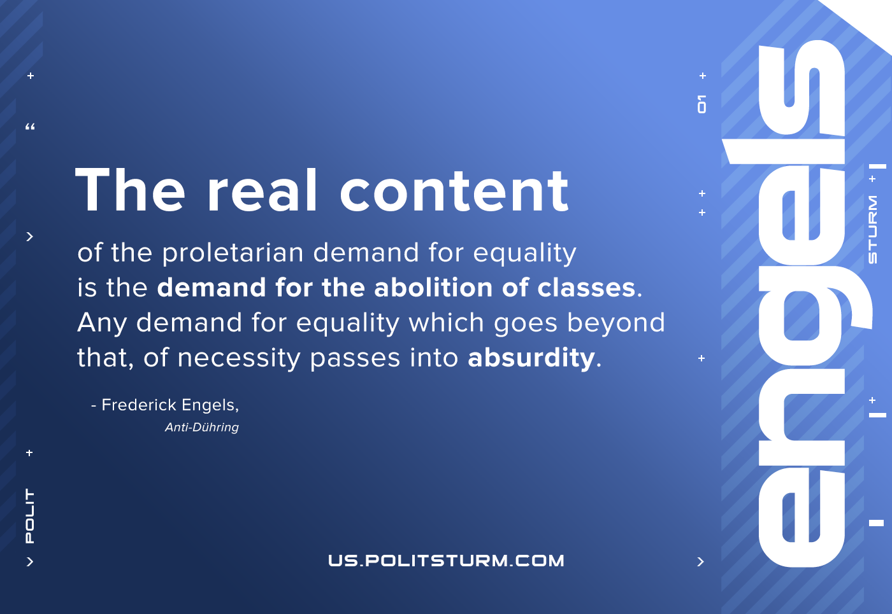

Original article
2021-03-04

The real content of the proletarian demand for equality is the demand for the abolition of classes. Any demand for equality which goes beyond that, of necessity passes into absurdity.
Engels, Anti-Dühring

Original article

