Engels on Democracy
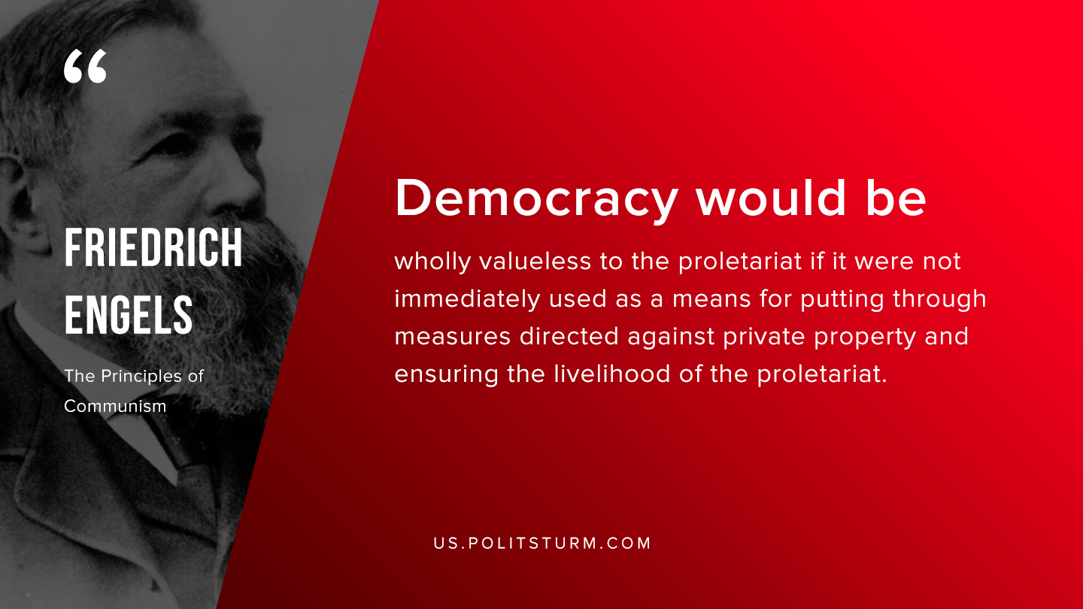

Original article
2019-08-10

Democracy would be wholly valueless to the proletariat if it were not immediately used as a means of putting through measures directed against private property and ensuring the livelihood of the proletariat.
Friedrich Engels “The Principles of Communism”

Original article

