Marx on Socialist Revolutions
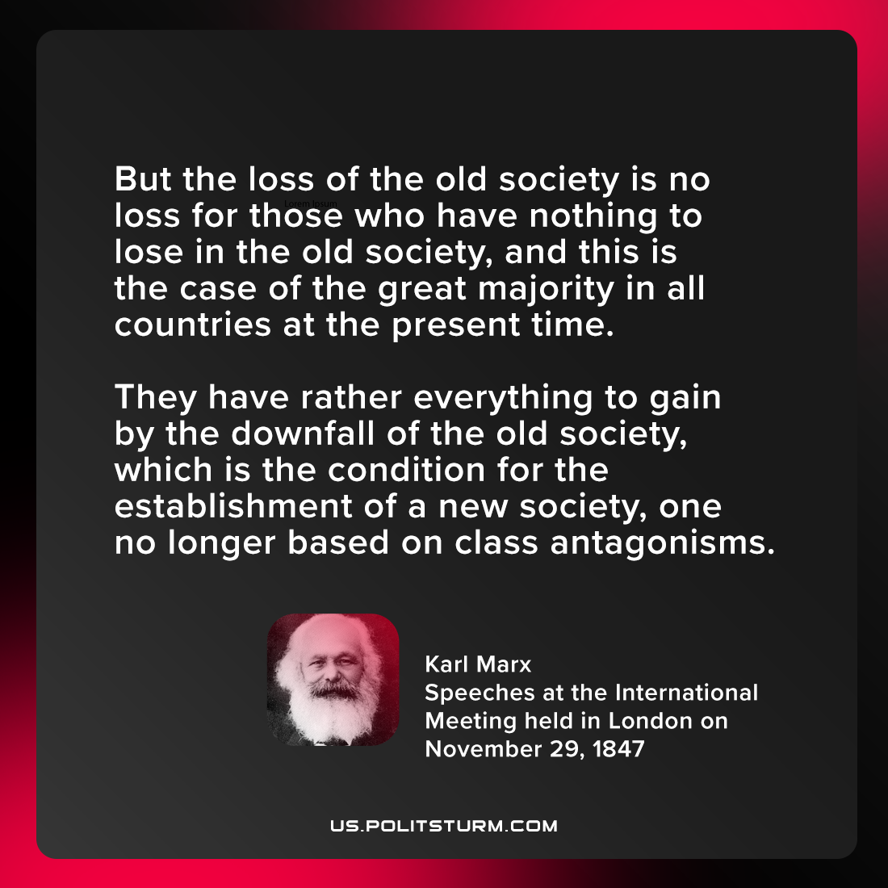

Original article
2021-08-31
1 min read

But the loss of the old society is no loss for those who have nothing to lose in the old society, and this is the case of the great majority in all countries at the present time. They have rather everything to gain by the downfall of the old society, which is the condition for the establishment of a new society, one no longer based on class antagonisms.

Karl Marx, “Speeches at the International Meeting held in London on November 29, 1847 to mark the 17th Anniversary of the Polish Uprising of 1830”

Original article

