Engels on Capitalist Claims of Societal Good
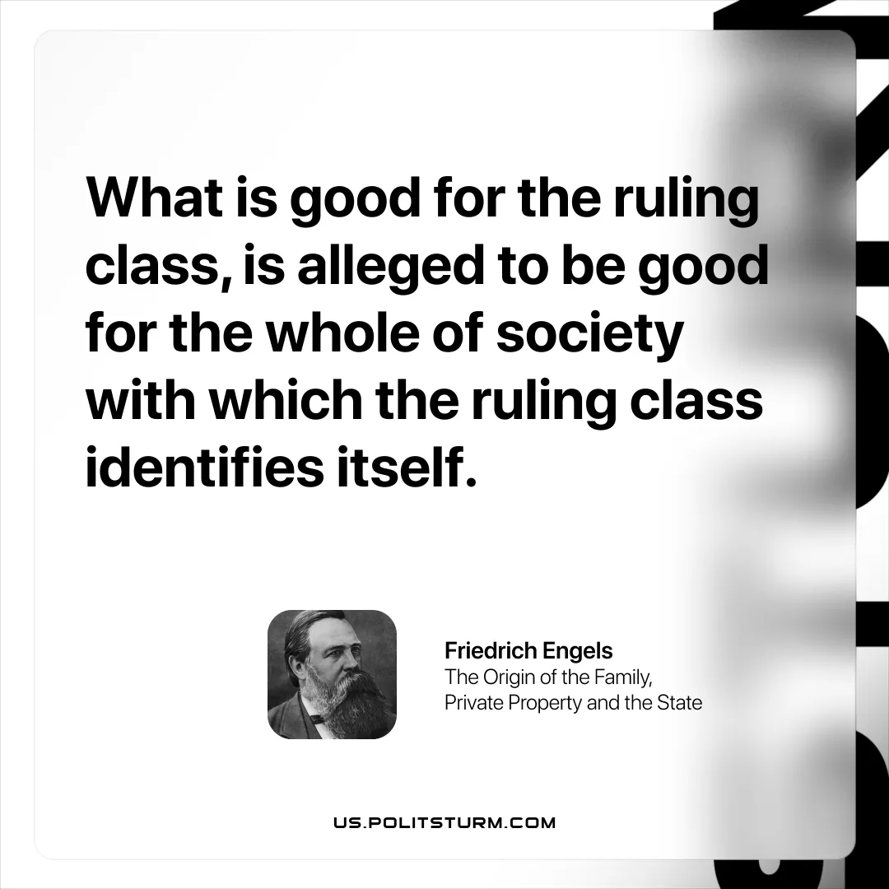

Original article
2026-04-02

“What is good for the ruling class, is alleged to be good for the whole of society with which the ruling class identifies itself.”
Friedrich Engels, The Origin of the Family, Private Property and the State

Original article

