Engels on Bourgeois History
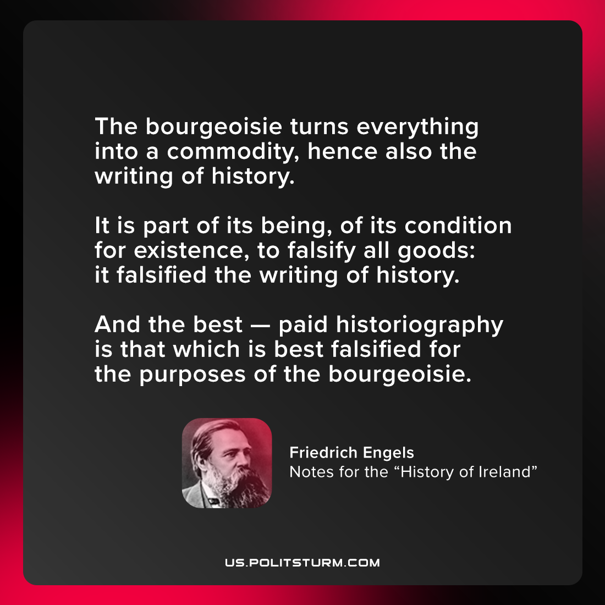

Original article
2021-07-14

The bourgeoisie turns everything into a commodity, hence also the writing of history. It is part of its being, of its condition for existence, to falsify all goods: it falsified the writing of history. And the best — paid historiography is that which is best falsified for the purposes of the bourgeoisie.

Friedrich Engels, “Notes for the “History of Ireland”

Original article

