Engels on Antagonism between Worker Class and Bourgeoisie
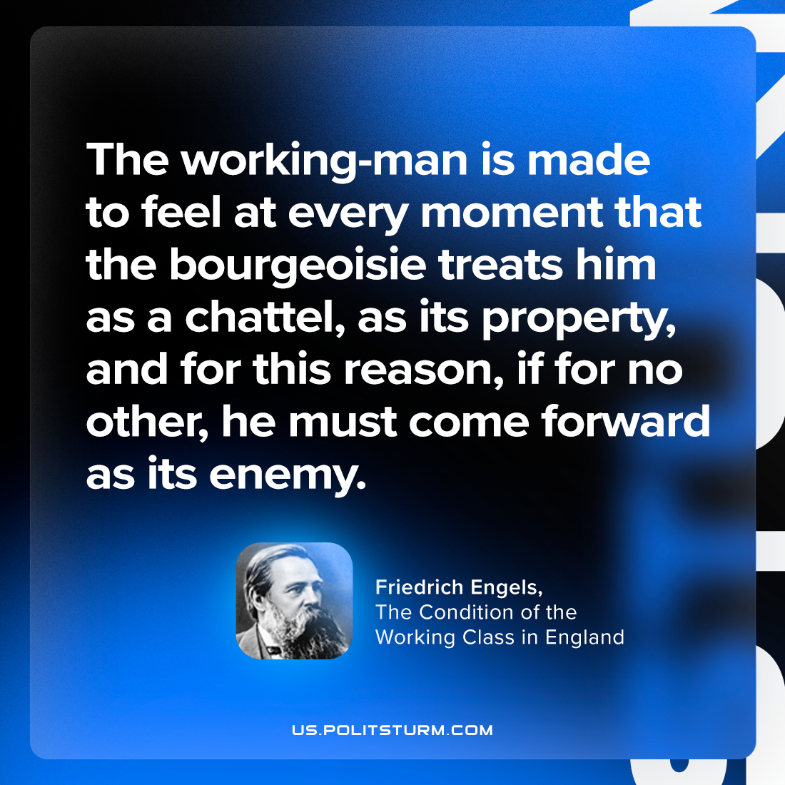

Original article
2024-01-16

"The working-man is made to feel at every moment that the bourgeoisie treats him as a chattel, as its property, and for this reason, if for no other, he must come forward as its enemy."
Friedrich Engels, The Condition of the Working Class in England

Original article

