Engels on "Abolition" of the State
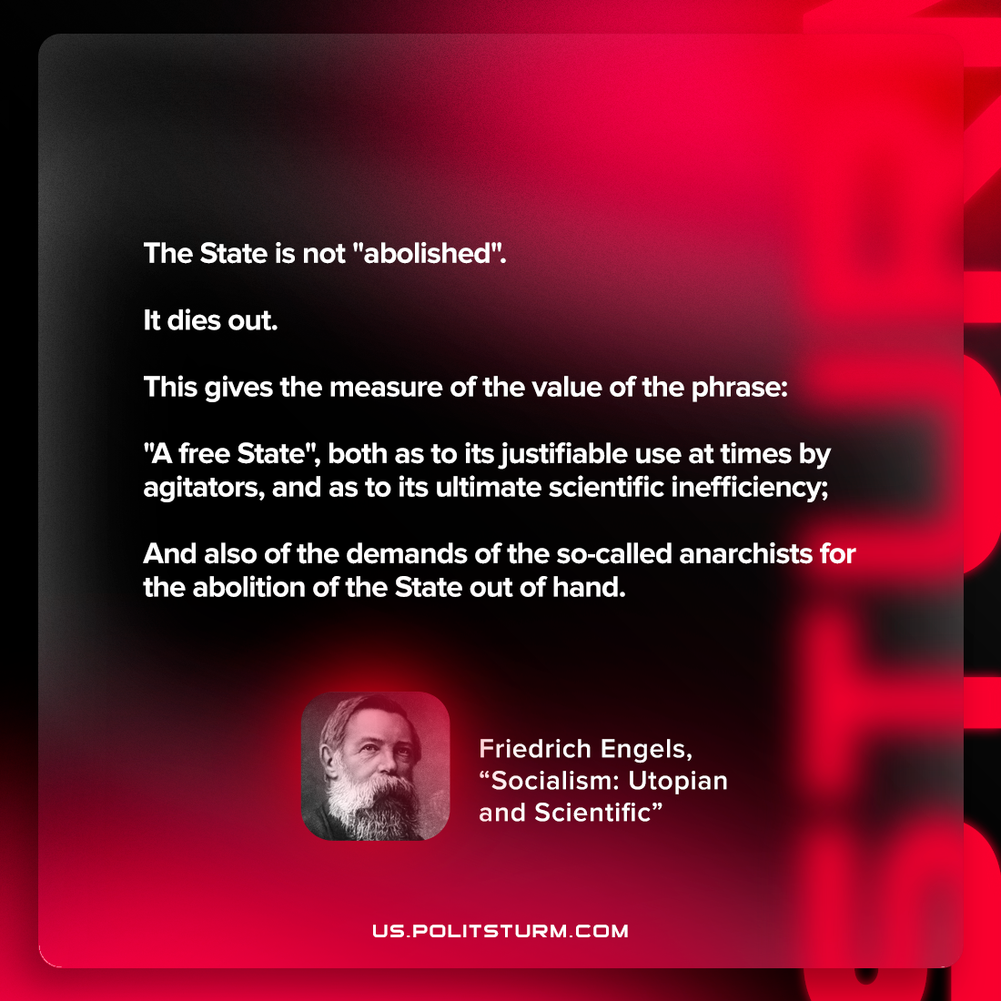

Original article
2023-02-02

"The State is not "abolished". It dies out. This gives the measure of the value of the phrase: "a free State", both as to its justifiable use at times by agitators, and as to its ultimate scientific inefficiency; and also of the demands of the so-called anarchists for the abolition of the State out of hand."
Friedrich Engels, “Socialism: Utopian and Scientific”

Original article

