Engels on a Communist Society
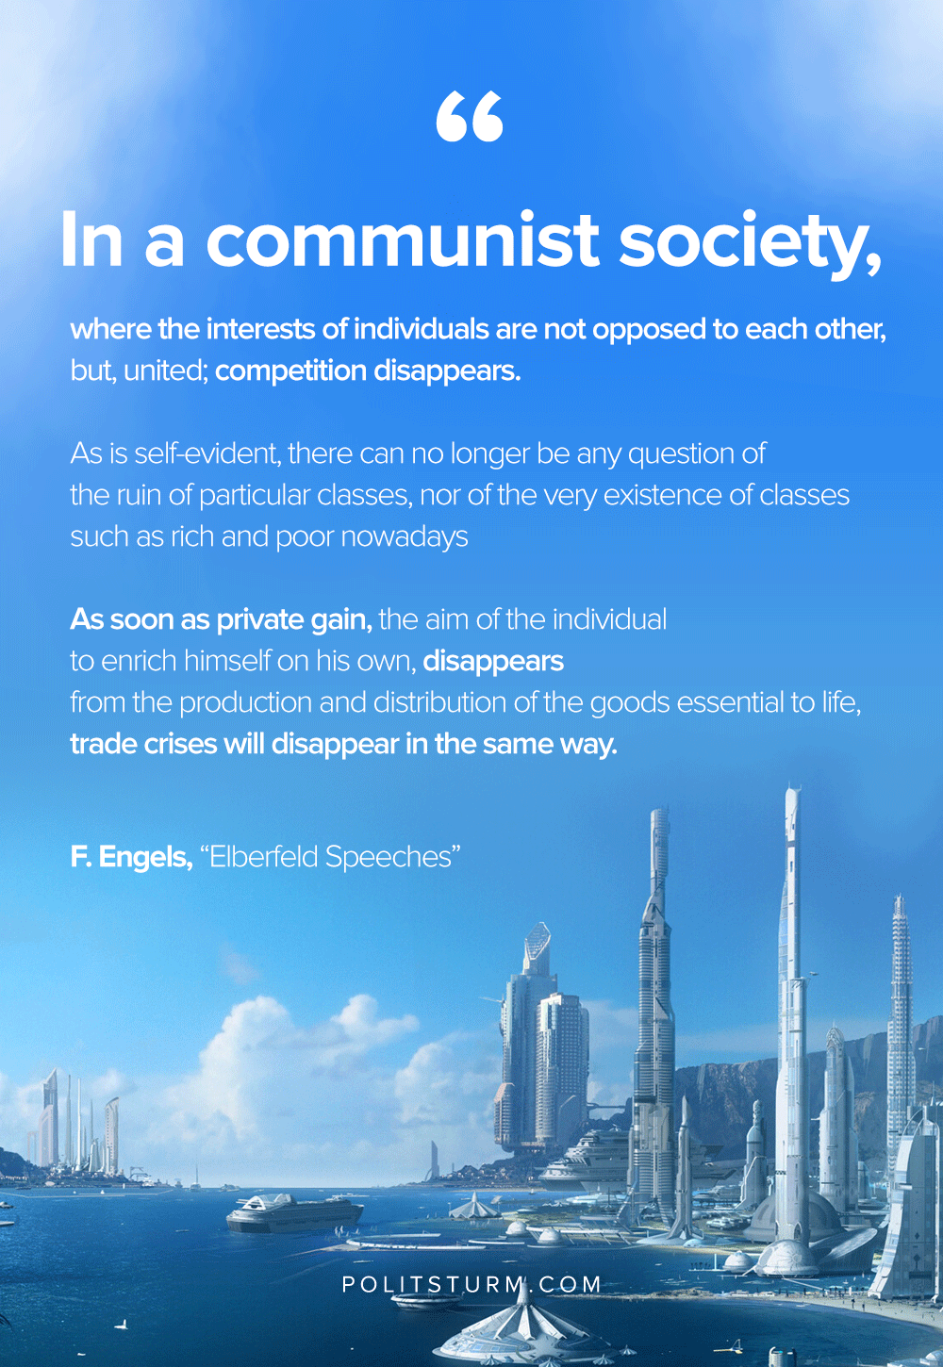

Original article
2020-04-29
1 min read

In communist society, where the interests of individuals are not opposed to one another but, on the contrary, are united, competition is eliminated. As is self-evident, there can no longer be any question of the ruin of particular classes, nor of the very existence of classes such as the rich and the poor nowadays. As soon as private gain, the aim of the individual to enrich himself on his own, disappears from the production and distribution of the goods necessary to life, trade crises will also disappear of themselves.
F.Engels, “Speeches in Elberfeld”

Original article

