Engels on the Basis of Capitalist Exploitation
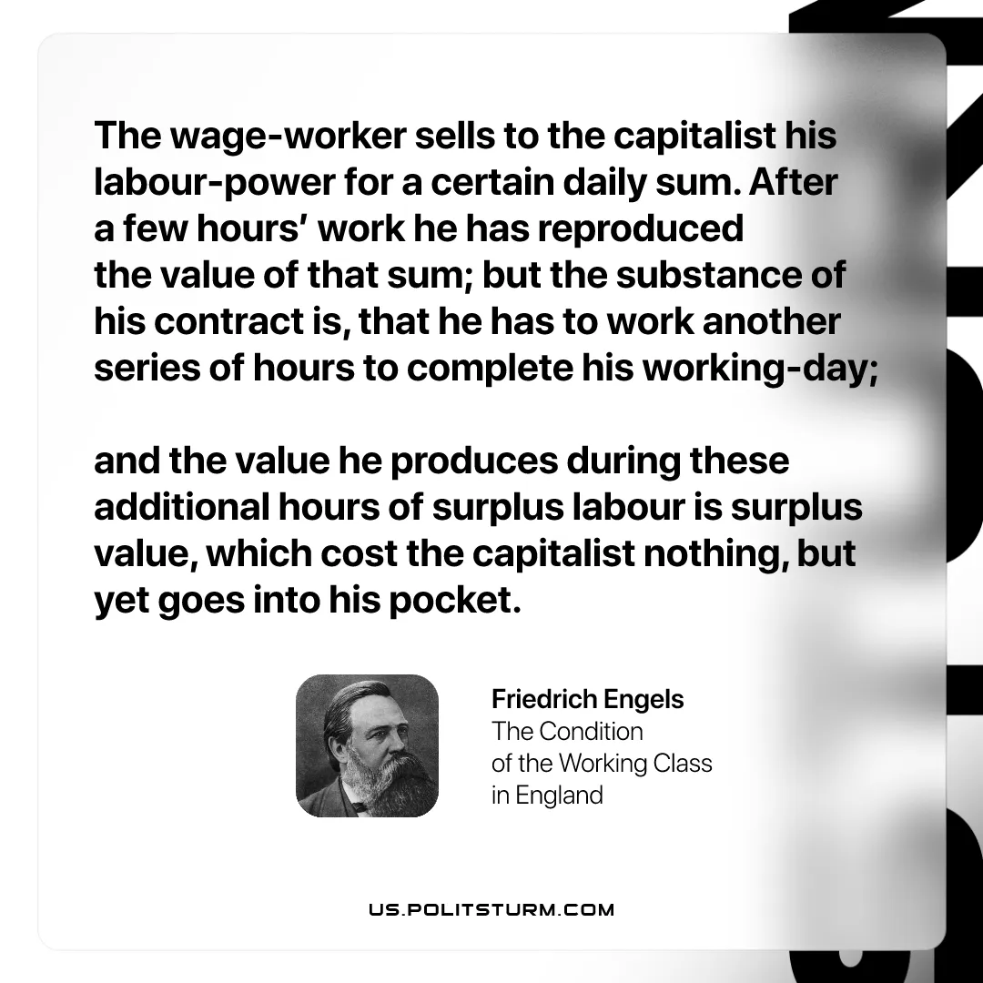

Original article
2026-04-11

“The wage-worker sells to the capitalist his labour-power for a certain daily sum. After a few hours’ work he has reproduced the value of that sum; but the substance of his contract is, that he has to work another series of hours to complete his working-day; and the value he produces during these additional hours of surplus labour is surplus value, which cost the capitalist nothing, but yet goes into his pocket.”
Friedrich Engels, The Condition of the Working Class in England

Original article

