Engels on the Permanent Class of Workers
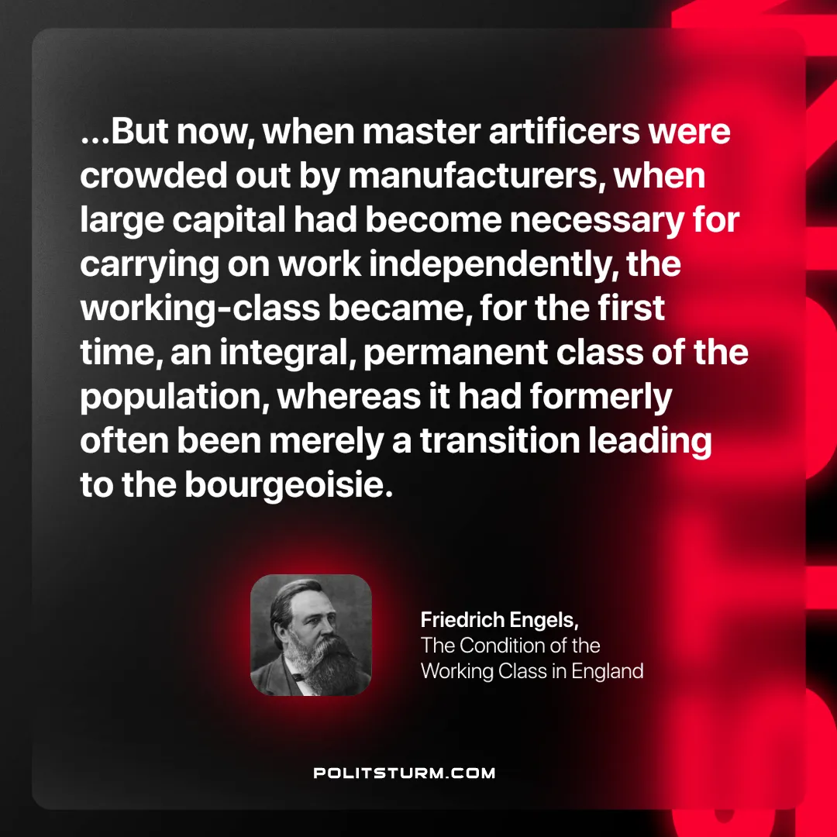

Original article
2025-01-21

“...But now, when master artificers were crowded out by manufacturers, when large capital had become necessary for carrying on work independently, the working-class became, for the first time, an integral, permanent class of the population, whereas it had formerly often been merely a transition leading to the bourgeoisie.”
Friedrich Engels, The Condition of the Working Class in England

Original article

